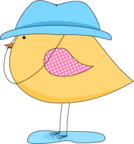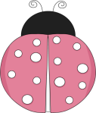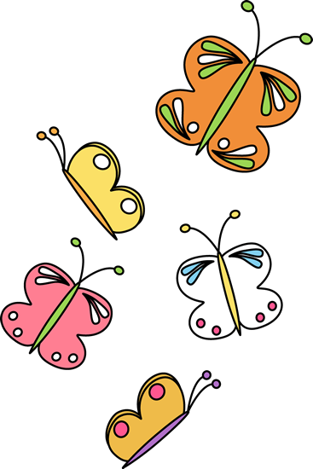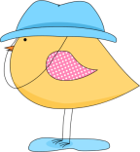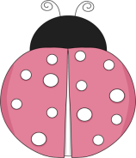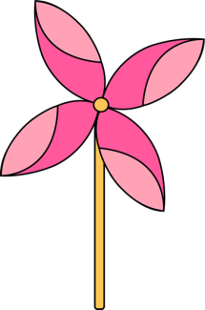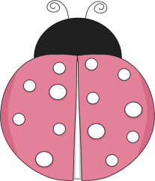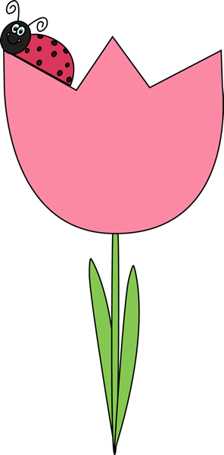

1. A spring month.

2. A spring flower.

3. The young of a chicken.

4. A colour of spring.

5. A young rabbit.

6. A flower especially of a fruit tree.

7. Plants that have narrow green leaves, that are eaten by cows, sheep, horses etc.

8. The fifth month of the year.

9. To come out of an egg.

10. See picture.

11. A rounded part of a plant that is under the ground and that grows into a new plant during the growing season.

12. A baby goat.

13. The place where a bird lays its eggs.

14. See picture.

15. Spring, winter, summer, fall!

16. What snow does in spring.

17. When the sun shines.

18. A long, thin animal that has a soft body with no legs or bones. It lives in the ground.

19. An indoor or outdoor spring activity.

20. To stop being frozen.

21. A baby sheep.

22. A small part that grows on a plant and develops into a flower, leaf, or new branch.

23. A baby horse.



K

D

F

O

A

1. A spring month.

2. A spring flower.

3. The young of a chicken.

4. A colour of spring.

5. A young rabbit.

6. A flower especially of a fruit tree.

7. Plants that have narrow green leaves, that are eaten by cows, sheep, horses etc.

8. The fifth month of the year.

9. To come out of an egg.

10. See picture.

11. A rounded part of a plant that is under the ground and that grows into a new plant during the growing season.

12. A baby goat.

13. The place where a bird lays its eggs.

14. See picture.

15. Spring, winter, summer, fall!

16. What snow does in spring.

17. When the sun shines.

18. A long, thin animal that has a soft body with no legs or bones. It lives in the ground.

19. An indoor or outdoor spring activity.

20. To stop being frozen.

21. A baby sheep.

22. A small part that grows on a plant and develops into a flower, leaf, or new branch.

23. A baby horse.

D

U

B

L

A

M

B

T

H

W

G

N

I

N

A

E

L

C

G

N

I

R

P

S

M

R

O

S

U

E

N

I

H

S

T

L

E

W

O

B

N

I

R

S

N

O

S

A

E

N

T

S

B

B

L

M

O

S

S

O

B

S

E

I

L

F

R

E

T

T

U

B

K

C

I

C

H

A

T

C

H

M

A

G

R

A

S

S

Y

N

N

B

N

E

E

R

G

T

U

L

P

L

I

R

P

A