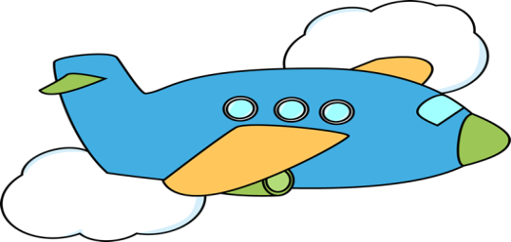

1. A 2-wheeled vehicle that a person rides by pushing on foot pedals.

2. A machine that flies through the air.

3. A car that carries passengers to a place for money.

4. A very large airplane that can carry many passengers.

5. A small vehicle that is used for traveling on water.

6. British for truck.

7. A very large and comfortable car usually driven by a professional driver.

8. A vehicle with two wheels that is powered by a motor and that can carry one or two people.

9. A system of tracks on which trains travel.

10. An electric vehicle that runs along the street on tracks.

11. A vehicle that is used for travel in outer space.

12. A child’s vehicle that is made of a narrow board with two small wheels attached underneath and an upright handle on top.

13. A boat that is used for catching fish with a large net.

14. A flat structure that is used for floating or sailing on water.

15. A small light vehicle with two wheels that is pulled by one person on foot or on a bicycle and that is used in some Asian countries.

16. A vehicle with four wheels.

17. Small aircraft that consists of a metal frame covered with strong cloth and that is flown through air by a person who hangs beneath it.

18. A light carriage that is usually pulled by one horse.

19. A large vehicle used for carrying many passengers.

