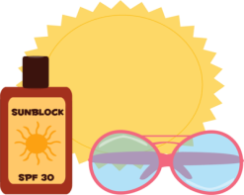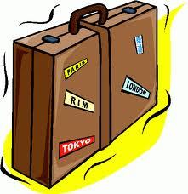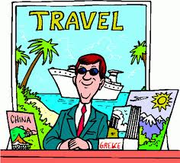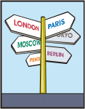

1. A piece of paper that allows you to travel on a vehicle.

2. A special piece of paper that you must have in order to be allowed to get onto an airplane.

3. An arrangement to have something (a room, a seat, a table) held for your use at a later time.

4. A person whose job is to help people who want to travel by buying tickets, making hotel reservations etc.

5. Another word for carry-on-luggage.

6. An official document issued by the government of a country that identifies someone as a citizen of a country and that is necessary when entering or leaving a country.

7. A place travelers can sleep and find other services.

8. Another word for make reservations.

9. Non-taxed.

10. A small thin book or magazine that usually has many pictures and information.

11. A shot given by a doctor to prevent infection.

12. What you do when you receive dollars for your kroner!

13. Situations in which something happens later than it should.

14. To decide that something will not happen.

15. A mark or stamp on a passport that allows someone to stay in a country.

-



V

I

S

1. A piece of paper that allows you to travel on a vehicle.

2. A special piece of paper that you must have in order to be allowed to get onto an airplane.

3. An arrangement to have something (a room, a seat, a table) held for your use at a later time.

4. A person whose job is to help people who want to travel by buying tickets, making hotel reservations etc.

5. Another word for carry-on-luggage.

6. An official document issued by the government of a country that identifies someone as a citizen of a country and that is necessary when entering or leaving a country.

7. A place travelers can sleep and find other services.

8. Another word for make reservations.

9. Non-taxed.

10. A small thin book or magazine that usually has many pictures and information.

11. A shot given by a doctor to prevent infection.

12. What you do when you receive dollars for your kroner!

13. Situations in which something happens later than it should.

14. To decide that something will not happen.

15. A mark or stamp on a passport that allows someone to stay in a country.

T

R

O

P

A

S

P

L

E

C

C

A

E

E

R

F

-

X

A

N

O

I

T

A

N

I

C

C

V

A

Y

D

L

C

H

A

N

G

E

E

R

U

H

C

O

R

B

K

O

B

N

O

I

T

A

D

O

M

M

O

C

C

E

G

A

G

G

U

L

D

H

A

T

N

E

G

A

L

E

V

A

T

S

A

S

P

G

N

I

D

B

O

A

R

E

S

E

R

V

A

N

O

I

T

K

E

C

I

T