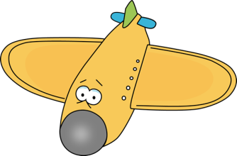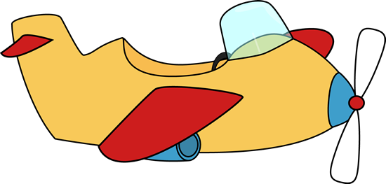

1. The money a person pays to travel on an airplane.

2. The bags, suitcases, and personal things that a person carries when travelling.

3. A small, simple house made of wood.

4. A journey on an airplane.

5. The activity of sleeping outdoors in a tent.

6. A person who leads or directs other people on a journey.

7. The places you go to or plan to go to on a journey.

8. A short vacation.

9. A place that has rooms where people can sleep when they are travelling.

10. An inexpensive place for usually young travelers to stay overnight.

11. A card with a message on one side and a picture on the other side.

12. To travel on a boat or ship.

13. A piece of paper that allows you to travel on a vehicle.

14. A house or hotel in the country or mountains.

15. A short trip.

16. A long journey to a distant or unknown place over water.

17. A place where people go for vacation.

18. The place at an airport or border where government officers collect customs on goods and look for things that people are trying to bring into a country illegally.













