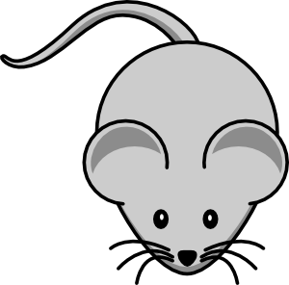





*Across:*

1. Goose – geese, mouse - ……..

4. A …….. lays eggs.

5. Give the book to him, it is ……..

7. Two ……. can see more than one.

*Down:*

1. Give it to ……, it is my book.

2. Where are pencils? They are …… the pencilcase.

3. One egg – two ……..

4. This is my house. I live ………

5. I – me, ….. –him

6. He …… standing up.

3

2

1

4

6

5

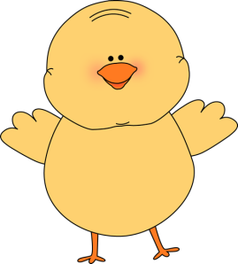

7





*Across:*

1. Opposite of old.

2. Colour of the lawn.

4. A conjunction used to indicate an alternative.

5. A small insect.

6. A connected line of railroad car.

*Down:*

1. It makes dough rise.

3. Not yes.

7. A hot drink.

2

3

1

4



7

5

6







*Across:*

1. Big, grey animal from Africa.

3. I use – He …….

*Down:*

2. Mike ………..Susan.

4. A book has many of them.

5. A fruit you can give your teacher.

6. I really appreciate your help! …… you!

6

5

4

2

1

3

