21
GO FORWARD 2 SQUARES
23
It is hot. Go for a swim.

22
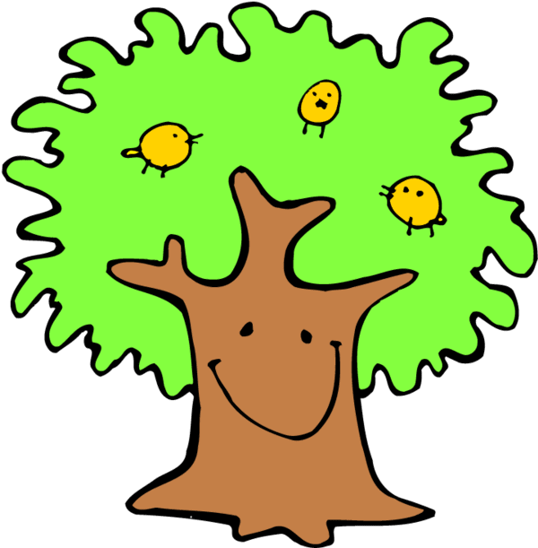
8
In which season does it rain a lot in your country?

13
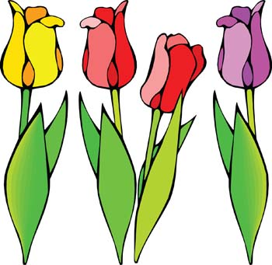

32

MISS A TURN

37
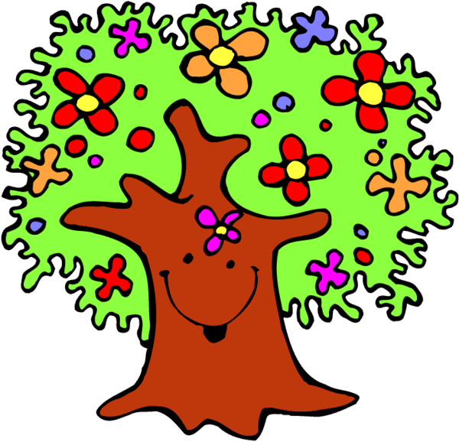

START
1
What day do you have English lesson?
4
In which month is Christmas?

3
How many months are there in a year?

2
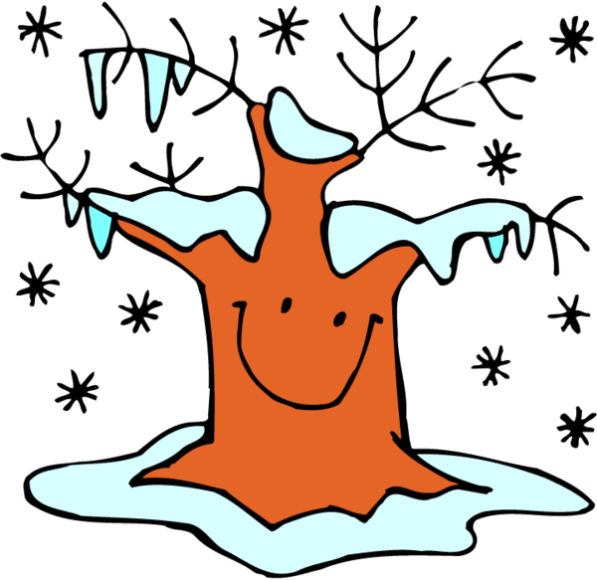

6
Which is your favorite season? Why?

7

MISS A TURN

9
Say the days of the week.
11
Say three things you can do on a hot summer day.
12
How many seasons are there in a year?

16

31
When is your birthday?
26
27
What is typical for summer in your country?
17
It’s snowing.
Build a snowman.

33
In what month is it hot in your country?
36
Do you celebrate Mother’s day? When?

38
When are your holidays?
39

41
GO BACK 3 SQUARES

42
Do you prefer winter or summer? Why?

43
Which season don’t you like? Why?
44
In which season is Easter?
45
What do you do when it’s very cold outside?
5
10
Say 2 sports you can do in winter.

14
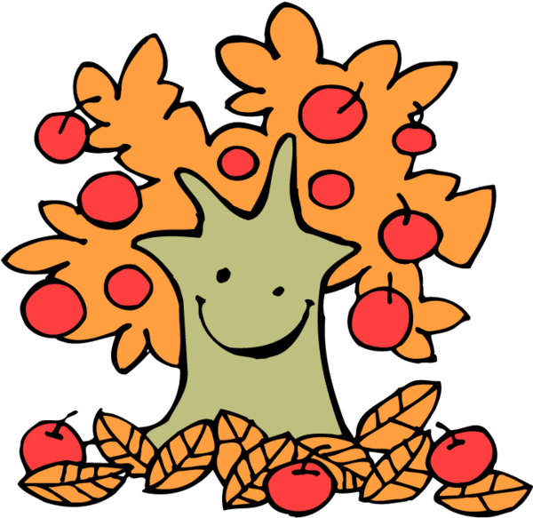
18
What is typical for winter in your country?
28
What’s the weather like today?
34
What is typical for fall in your country?
40
Do you prefer hot or cold weather?

FINISH
15
What is typical for spring in your country?
19
Go and pick some tulips.
24
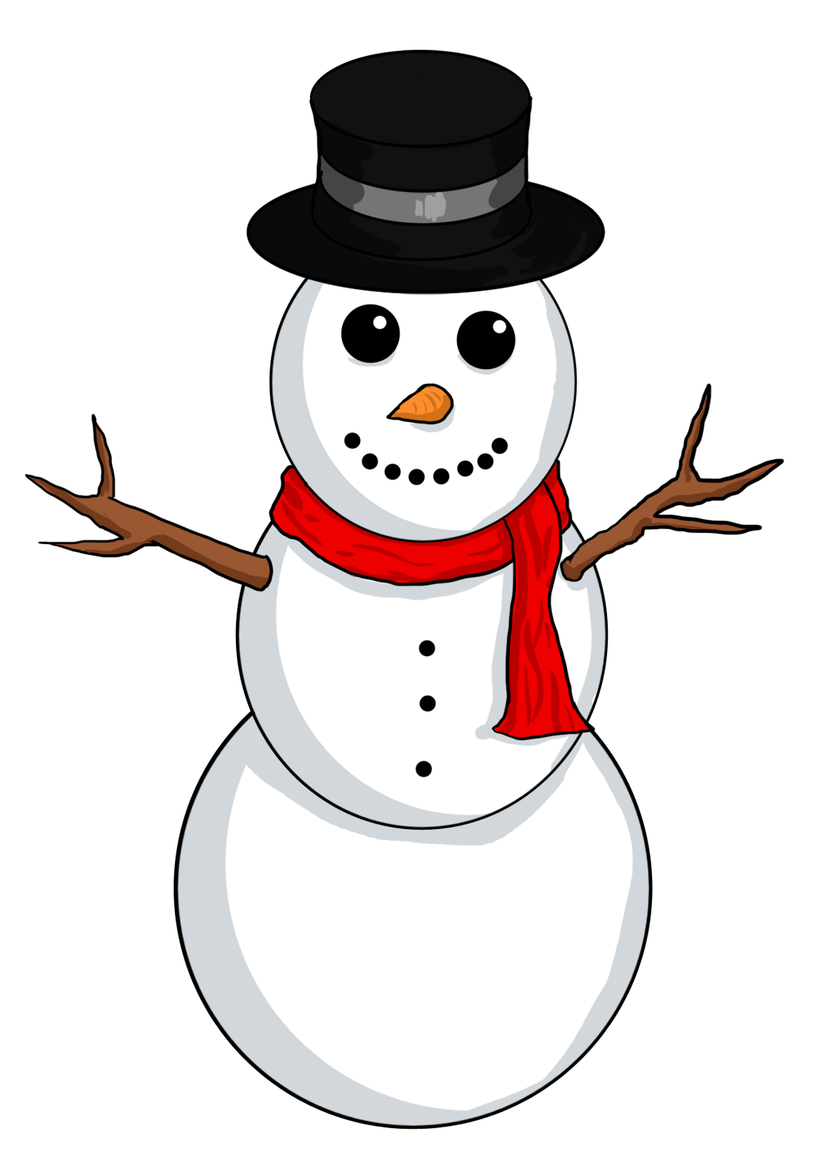
25
What is your favorite day? Why?
29

GO BACK 3 SQUARES

20
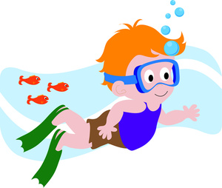

30
It is a nice fall day. Go and fly a kite.

35
21
GO FORWARD 2 SQUARES
23
It is hot. Go for a swim.

22
summer
8
In my country it rains a lot in January and February.

13
tulips

32

MISS A TURN

37

START
1
I have English on...
4
Christmas is in December.

3
There are twelve month.

2
winter

6
I prefer summer because it’s warm.

7

MISS A TURN

9 Monday, Tuesday, Wednesday, Thursday,
Friday, Saturday
Sunday
11
I can swim, surf, and dive.
12
There are four seasons.

16

31
It’s in October
26
27
It is very hot.
17
It’s snowing.
Build a snowman.

33
In December.
36
Yes, we do. In May.

38
My holidays are in July.
39

41
GO BACK 3 SQUARES

42
Summer because I can go swimming.

43
I don’t like winter. It’s cold.
44
It’s in spring.
45
I stay at home and watch TV.
5
10
I can ski.
I can go ice skating.

14
fall
18
It is cold. It snows.
28
It is cloudy.
34
The leaves change color.
40
I prefer hot weather.

FINISH
15
The trees are blooming.
19
Go and pick some tulips.
24
snowman
25
It’s Sunday. I can stay in bed?
29

GO BACK 3 SQUARES

20
swim

30
It is a nice fall day. Go and fly a kite.

35
fly a kite

Instructions for the teacher.

Preparation
- Print the board games on tick paper or a cardboard; laminate them if you want to use them many times.
- Find tokens for each student.
- Provide dice.
- Divide the class into groups of 3 – 4 students each.
- Give each group a board game and a die.
- Give each student a token (or bean, coin, button, etc.).

The game
- The players put their tokens on the first square.
- The first student throws the die and moves his token ahead the corresponding number of squares.
- The student answers the question with a whole sentence or follows the instructions. If he arrives on a picture, he says what it is.
- Example: It’s spring.
I have English lesson on Monday. If the student is more advanced, he could add more sentences . It is spring. There are lots of flowers, the weather is nice.
- If the answer is correct, the student stays, if the answer is incorrect, he has to go back where he came from.
- If the student comes to a square with the symbol , he rolls the die again.
- The first student who takes a number that places his token on “FINISH” or surpasses it is the winner.

