**Die Steigerung des Adjektivs**

[](http://www.google.at/url?sa=i&rct=j&q=&esrc=s&source=images&cd=&cad=rja&uact=8&ved=0ahUKEwj3gqnC0tnLAhWBmBoKHfG-CzkQjRwIBw&url=http://de.gofreedownload.net/free-vector/vector-clip-art/simple-flower-clip-art-128753/&psig=AFQjCNESjw1MGO_bNGMt3trIXFbHee5s7A&ust=1458919908520264) [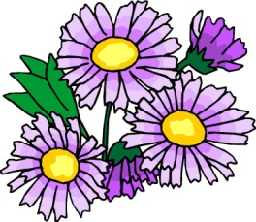](http://www.google.at/url?sa=i&rct=j&q=&esrc=s&source=images&cd=&cad=rja&uact=8&ved=0ahUKEwje6MOC09nLAhXGbBoKHVk2C-8QjRwIBw&url=http://www.picgifs.com/clip-art/flowers/&p=9/&psig=AFQjCNESjw1MGO_bNGMt3trIXFbHee5s7A&ust=1458919908520264) [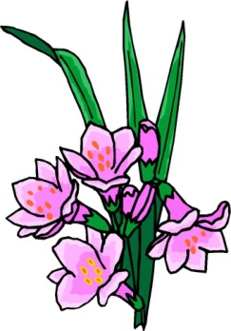](http://www.google.at/url?sa=i&rct=j&q=&esrc=s&source=images&cd=&cad=rja&uact=8&ved=0ahUKEwiRjPqt09nLAhUL6xoKHYD4BBIQjRwIBw&url=http://kochenlernen.tk/cliparts-kostenlos-blumen/&psig=AFQjCNESjw1MGO_bNGMt3trIXFbHee5s7A&ust=1458919908520264)Die Blume ist……..

schön schön**er** am schön**sten**

[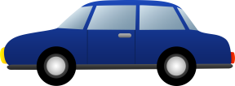](http://www.google.at/url?sa=i&rct=j&q=&esrc=s&source=images&cd=&cad=rja&uact=8&ved=0ahUKEwicuITh09nLAhXIXBoKHUAzAJQQjRwIBw&url=http://www.clipartpanda.com/categories/family-car-clipart&bvm=bv.117604692,d.d24&psig=AFQjCNEhvDn8NmHZzwTjXLcOCmwJR09cNQ&ust=1458920279396536) [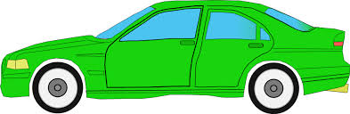](http://www.google.at/url?sa=i&rct=j&q=&esrc=s&source=images&cd=&cad=rja&uact=8&ved=0ahUKEwjvisr909nLAhXDthoKHX_ICg0QjRwIBw&url=http://www.clker.com/clipart-10911.html&bvm=bv.117604692,d.d24&psig=AFQjCNEhvDn8NmHZzwTjXLcOCmwJR09cNQ&ust=1458920279396536) [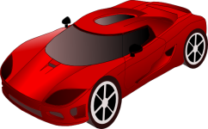](http://www.google.at/url?sa=i&rct=j&q=&esrc=s&source=images&cd=&cad=rja&uact=8&ved=0ahUKEwj64aOT1NnLAhVKnBoKHa9zA_cQjRwIBw&url=http://cliparts.co/auto-racing-clip-art&bvm=bv.117604692,d.d24&psig=AFQjCNEhvDn8NmHZzwTjXLcOCmwJR09cNQ&ust=1458920279396536) Das Auto ist …

schnell schnell**er** am schnell**sten**

[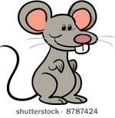](http://www.google.at/url?sa=i&rct=j&q=&esrc=s&source=images&cd=&cad=rja&uact=8&ved=0ahUKEwjpif_Z1NnLAhWB2RoKHcvNBhQQjRwIBw&url=http://www.vecteezy.com/free-vector/mouse-trap&bvm=bv.117604692,d.d24&psig=AFQjCNFPCFoOLJF2KmygAqcr8pYlVvYzvg&ust=1458920528014787) [](http://www.google.at/url?sa=i&rct=j&q=&esrc=s&source=images&cd=&cad=rja&uact=8&ved=0ahUKEwjpif_Z1NnLAhWB2RoKHcvNBhQQjRwIBw&url=http://www.vecteezy.com/free-vector/mouse-trap&bvm=bv.117604692,d.d24&psig=AFQjCNFPCFoOLJF2KmygAqcr8pYlVvYzvg&ust=1458920528014787) [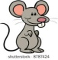](http://www.google.at/url?sa=i&rct=j&q=&esrc=s&source=images&cd=&cad=rja&uact=8&ved=0ahUKEwjpif_Z1NnLAhWB2RoKHcvNBhQQjRwIBw&url=http://www.vecteezy.com/free-vector/mouse-trap&bvm=bv.117604692,d.d24&psig=AFQjCNFPCFoOLJF2KmygAqcr8pYlVvYzvg&ust=1458920528014787) Die Maus ist……..

klein klein**er** am klein**sten**

|  |  |  |
| --- | --- | --- |
| gut |  |  |
| lieb |  |  |
| groß |  |  |
| dick |  |  |
| dünn |  |  |
| alt |  |  |

[](http://www.google.at/url?sa=i&rct=j&q=&esrc=s&source=images&cd=&cad=rja&uact=8&ved=0ahUKEwjrr4m2_9nLAhXD1RoKHYdYBVoQjRwIBw&url=http://www.gif-paradies.de/kleidung/&psig=AFQjCNG2PeAE3JsJAChanYmV6IxsVN7QdA&ust=1458931981817421)Welches Kleid gefällt dir **besser**? [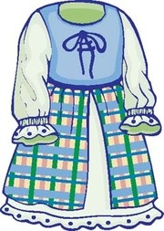](http://www.google.at/url?sa=i&rct=j&q=&esrc=s&source=images&cd=&cad=rja&uact=8&ved=0ahUKEwjMzY_j_9nLAhWCzBoKHbUiAVEQjRwIBw&url=http://de.clipart.me/free-vector/dress&psig=AFQjCNG2PeAE3JsJAChanYmV6IxsVN7QdA&ust=1458931981817421)

[](http://www.google.at/url?sa=i&rct=j&q=&esrc=s&source=images&cd=&cad=rja&uact=8&ved=0ahUKEwjEr-z-_9nLAhWEtBoKHT-RCoQQjRwIBw&url=http://www.insomniaku.co/2015/02/mengobati-insomnia-dengan-ceri.html&bvm=bv.117604692,d.bGs&psig=AFQjCNHbzx00bZDm_AHA1Oq5OVhvGt893g&ust=1458932153206309)Welches Obst magst du **lieber**? [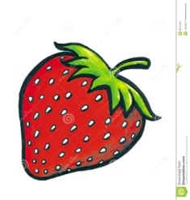](http://www.google.at/url?sa=i&rct=j&q=&esrc=s&source=images&cd=&cad=rja&uact=8&ved=0ahUKEwiMss6RgNrLAhXJlxoKHarTAy8QjRwIBw&url=http://cn.dreamstime.com/%E5%85%8D%E7%89%88%E7%A8%8E%E5%BA%93%E5%AD%98%E5%9B%BE%E7%89%87-%E4%B8%80%E4%B8%AA%E7%BA%A2%E8%89%B2%E8%8D%89%E8%8E%93-image8614456&bvm=bv.117604692,d.bGs&psig=AFQjCNHbzx00bZDm_AHA1Oq5OVhvGt893g&ust=1458932153206309)

[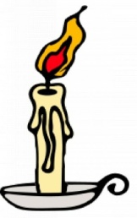](http://www.google.at/url?sa=i&rct=j&q=&esrc=s&source=images&cd=&cad=rja&uact=8&ved=0ahUKEwjh8qnCgNrLAhXLvBoKHdzUAQMQjRwIBw&url=http://de.freepik.com/fotos-vektoren-kostenlos/candle-clip&bvm=bv.117604692,d.bGs&psig=AFQjCNHdGBK1cz847zaWsUwBTBLxIWO75Q&ust=1458932306420590) Was leuchtet **heller**? [](http://www.google.at/url?sa=i&rct=j&q=&esrc=s&source=images&cd=&cad=rja&uact=8&ved=0ahUKEwibvYPegNrLAhVI0xoKHaZLDS4QjRwIBw&url=http://www.clipartsfree.de/clipart-bilder-galerie/business-bilder-clipart-free/idee-gluehbirne-clipart-3059.html&bvm=bv.117604692,d.bGs&psig=AFQjCNFRZh0Fg2ckYFkUnMxdAkVG4FSsIg&ust=1458932359786172)

[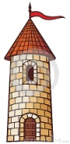](http://www.google.at/url?sa=i&rct=j&q=&esrc=s&source=images&cd=&cad=rja&uact=8&ved=0ahUKEwi0_7GugdrLAhWBuBoKHYDnBOkQjRwIBw&url=http://de.dreamstime.com/illustration/schloss-turm.html&bvm=bv.117604692,d.bGs&psig=AFQjCNG8q8kJxaL_gEmxMerH-AbSqaNuYQ&ust=1458932531437690) [](http://www.google.at/url?sa=i&rct=j&q=&esrc=s&source=images&cd=&cad=rja&uact=8&ved=0ahUKEwifh7TggdrLAhXKORoKHczJA1YQjRwIBw&url=http://publicdomainvectors.org/de/tag/Wohnung&bvm=bv.117604692,d.bGs&psig=AFQjCNETi8_Nmhn6OtIpKSQc0PoCjcPdNw&ust=1458932588602801) [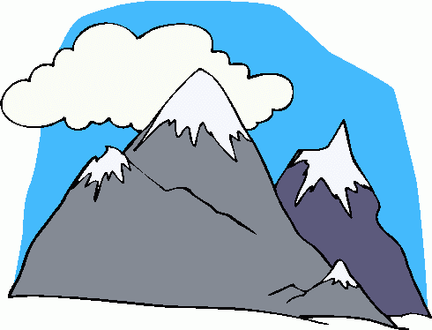](http://www.google.at/url?sa=i&rct=j&q=&esrc=s&source=images&cd=&cad=rja&uact=8&ved=0ahUKEwjfsK6KgtrLAhVMBBoKHSceDe0QjRwIBw&url=http://www.clipartpanda.com/categories/mountain-clip-art-black-and-white&bvm=bv.117604692,d.bGs&psig=AFQjCNHHkcNYbfUi7qjrxIxof4y7qpuXMA&ust=1458932714364418)

Der Turm ist **hoch**.

Das Haus ist **höher**.

Der Berg ist **am höchsten.**

[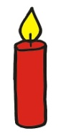](http://www.google.at/url?sa=i&rct=j&q=&esrc=s&source=images&cd=&cad=rja&uact=8&ved=0ahUKEwjUg8PzjdvLAhXGMhoKHS1eD9wQjRwIBw&url=http%3A%2F%2Fwww.experto.de%2Fhobby-freizeit%2Fkreativitaet%2Fverschoenern-sie-ihre-weihnachtspost-mit-10-kostenlosen-cliparts%2Ffotostrecke%2F11077%2Fpic%2F4.html&bvm=bv.117868183,d.d24&psig=AFQjCNEG5x3Eft2VH72yY_DvLmH4Ql6cNw&ust=1458970259017985) [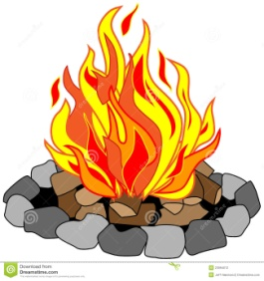](http://www.google.at/url?sa=i&rct=j&q=&esrc=s&source=images&cd=&cad=rja&uact=8&ved=0ahUKEwi69KWHjtvLAhVMOBQKHbbKCU8QjRwIBw&url=http%3A%2F%2Fwww.dreamstime.com%2Fstock-photography-roaring-campfire-image23094012&bvm=bv.117868183,d.d24&psig=AFQjCNE6l4UmwSerKo_v47TRPSnjqHSE2Q&ust=1458970297184299) [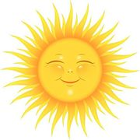](http://www.google.at/url?sa=i&rct=j&q=&esrc=s&source=images&cd=&cad=rja&uact=8&ved=0ahUKEwj8y8apjtvLAhWCzxoKHREdBpgQjRwIBw&url=http%3A%2F%2Fwww.fotosearch.de%2Fclip-art%2Fsonne.html&bvm=bv.117868183,d.d24&psig=AFQjCNGZKHwB6c2mgcR3N5r7qm2-9Z9S2A&ust=1458970339642067)

Die Kerze ist **heiß.**

Das Feuer ist **heißer.**

Die Sonne ist am **heißesten.**

Gestern war es kalt. Heute ist es kälter. Morgen ist es am kältesten.

Ich bin jung. Du bist jünger. Es ist am jüngsten.

K.D.