Die Zahlen von 0 bis 20

Fill in the missing number words!
eins, zwei, ______________________ vier, ____________________, sechs, ____________________,
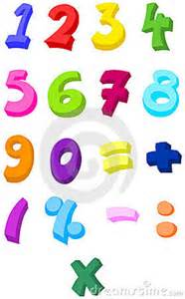
acht, _____________________, _______________________
Write the number beside the word!
- Elf ___________
- Neun_________
- Sechzehn______
- Zwanzig_______
- Vierzehn ______
- Drei __________
- Sieben ________
- Null __________
- Zwei _________
- Zwölf_________
Cross out the wrong number word!
- Eins zwei drei fünf
- Zehn neun acht sechs
- Zwölf acht neun zehn
- Fünfzehn neunzehn sechzehn sebzehn
- Zwanzig neunzehn sechs siebzehn
Write the numberword beside the figure!
- 12_________________________________________________________________________
- 17_________________________________________________________________________
- 14_________________________________________________________________________
- 9_________________________________________________________________________
- 4_________________________________________________________________________
- 11_________________________________________________________________________
- 6_________________________________________________________________________
- 5_________________________________________________________________________
- 1_________________________________________________________________________
- 0_________________________________________________________________________
- 2_________________________________________________________________________
- 7_________________________________________________________________________
- 3_________________________________________________________________________

