Grammar Translation Method
www.eegitimim.com

1 ) Most of the interaction in a GMT classroom is …………………………..
= from the teacher to the students
2 ) Foreign language learning is the GMT is viewed as a mental exercise because
= students grow intellectually by being aware of the grammatical rules of their own
language through the study of the target language.

3 ) In GMT pronunciation is considered unimportant for language learn .

4 ) In GMT , learning is facilitated through attention to similarities between the target language and
the native language.

5 ) Because the teacher is authority , there is little student –student interaction.

6 ) In GMT the skills of listening and speaking are ignored.

7 ) The purpose of learning a foreign language in GMT is to be able to read and appreciate foreign
lanuage literature.

8 ) The teaching of irregular verbs is studied in GMT through memorizing.

9 ) GMT basically dwells on the form of the target language.

10 ) Native language use in GMT classrooms is a way of foreign language instruction.

11 ) In GMT the students read a literary piece and produce answer to comprehension questions.
** In GMT ,deductive application of an explicit grammar rule is a useful technique .
** The teacher decided whether an answer is correct or not. If the answer is incorrect, the teacher selects a different student to give the correct answer , or the teacher herself gives the right answer.
It’s very important that students get the correct answer.

The Techniques used in GMT
1 ) Translation of a literary passage
2 ) Reading comprehension questions
3 ) Antonyms / synonyms
4 ) Cognates = station * istasyon
5 ) Deductive application of rule = Grammar rules are presented with examples.Once students understand a rule , they are asked to apply it some dfferent examples.
6 ) Fill in the blanks
7 ) Memorization
8 ) Use words in sentences
9 ) Composition
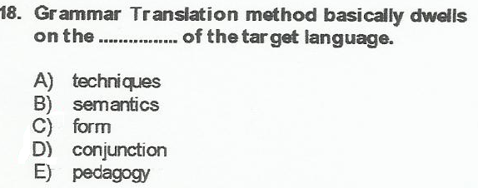

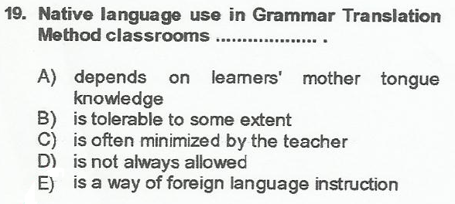

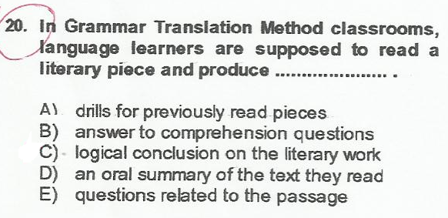

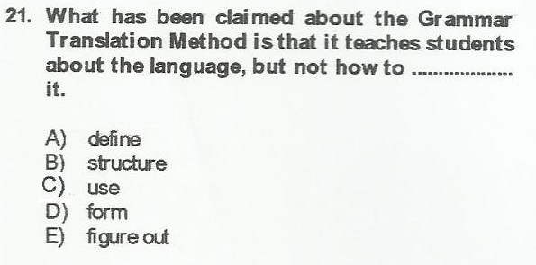

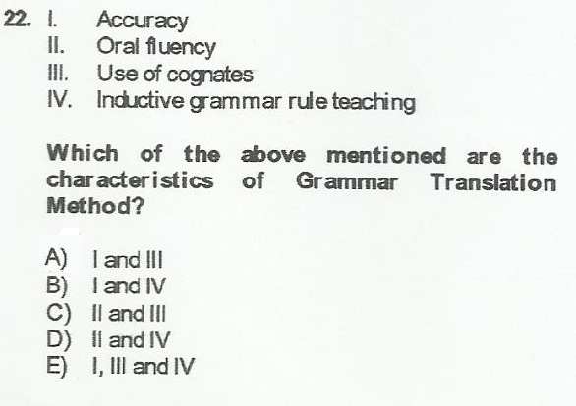

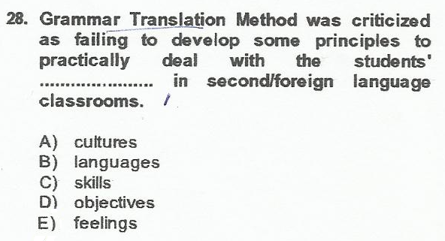

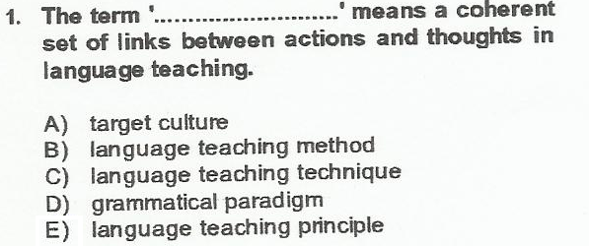

[Belgeden bir alıntı veya ilginç bir noktanın özetini yazın. Metin kutusunu belgede istediğiniz yere yerleştirebilirsiniz. Kısa alıntı metin kutusunun biçimlendirmesini değiştirmek için Çizim Araçları sekmesini kullanın.]
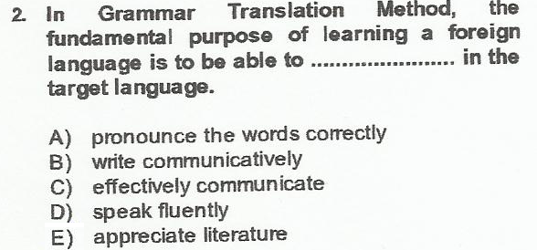

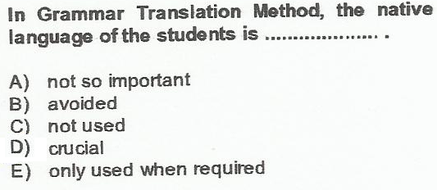

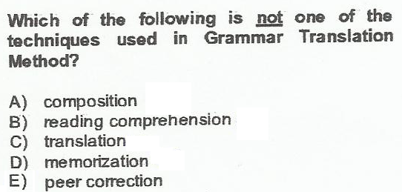

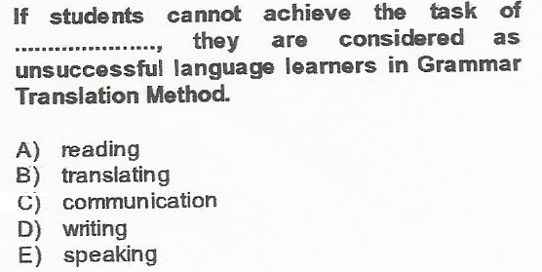

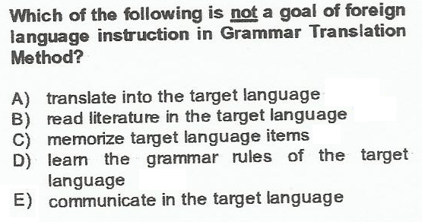

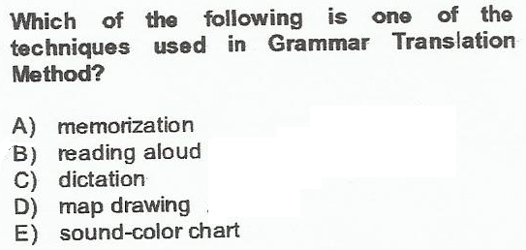

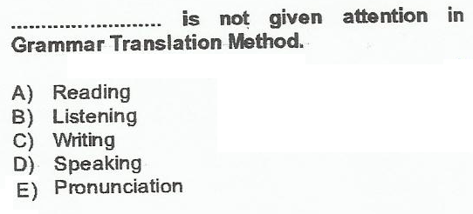

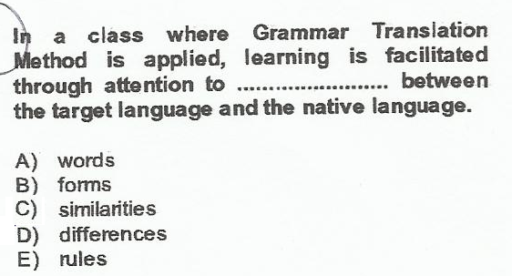

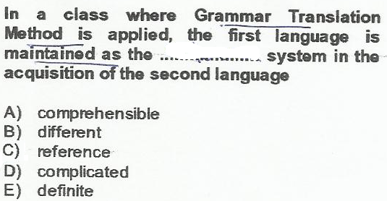

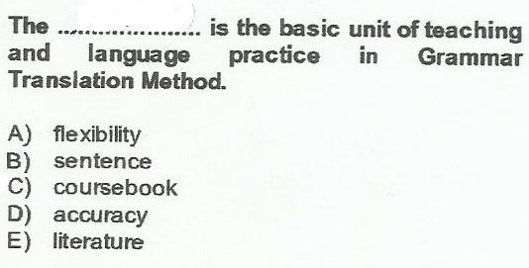

The Direct Method
** To help students understand the meaning in Direct Method classrooms realia ( gerçek nesneler ) or pictures ( like a map )
** A Direct Method teacher should not tolerate the use of native language .
** In Direct Method , the teacher mostly answers students’ questions using demonstration instead
of translation.
** Self – correction is the significant principle in Direct Method .
** In Direct Method classroom language learners are encouraged to speak.
** The teaching of grammar should be done inductively in Direct Method.
Deductive = Learners are given the rule and asked to aplly it.
Inductive = Learners discover the rules from examples and then practise it.

** In order to develop learners’ writing ability , In Direct Method teacher dictates a paragraph.
** A Direct Method is primarily based on situations and topics.
** In Direct Method interaction goes from teacher to student or student to teacher.
** In Direct Method classrooms , teacher not only focus on reading but also speaking and
writing.
In Direct Method , self –correction is made
a ) By using a questioning voice to signal that something was wrong.
b ) By repeating the student’s answer with a pause just before the error
c ) By giving an alternative answer to the student to choose.
** In Direct Method fill in the blank exercises are used to induce a grammar rule.
** In Direct Method teacher is asking students questions about themselves to practice language in context.

** The teacher asks questions about the map in the target language = Students should learn to think in the target language as soon as possible.
** The teacher asks questions about the students ; students ask each other questions = Language should contain some conversational activity , some opportunity for students use language in real
contexts. Students should encourage to speak as much as possible.

**In Direct Method the syllabus is based on situations or topics ; not usually on linguistic instruction.
**In Direct Method students need to associate meaning and the target language directly.
**In Direct Method students students study everyday speech in the target language.
The Techniques used The Direct Method
1 ) Reading aloud 5 ) Fill in the blank exercise
2 ) Question and answer exercise 6 ) Dictation
3 ) Get students to self –correct 7 ) Map drawing
4 ) Conversation practise 8 ) Paragraph writing

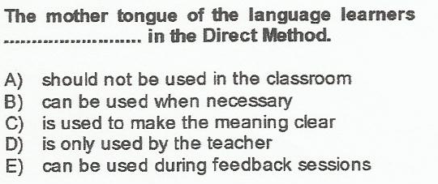

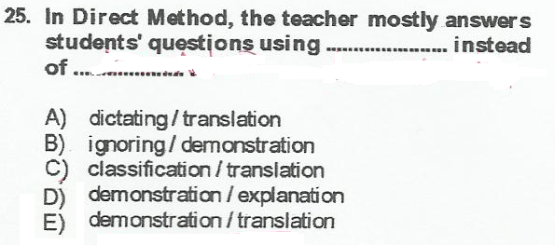

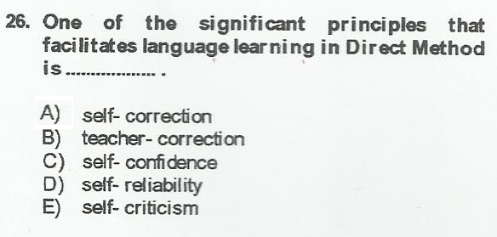

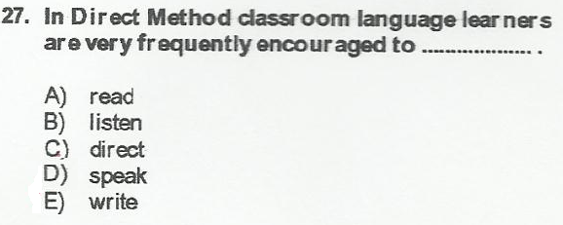

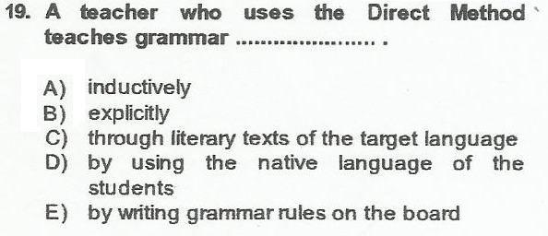

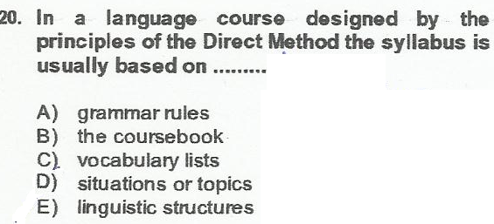

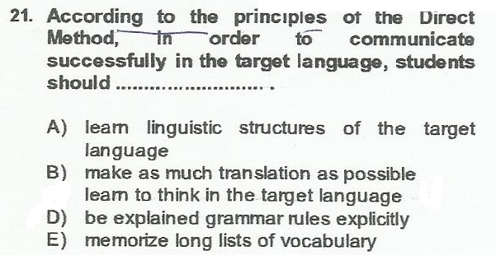

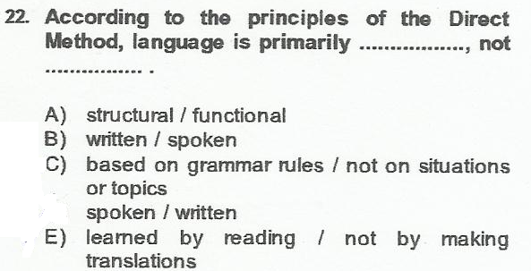

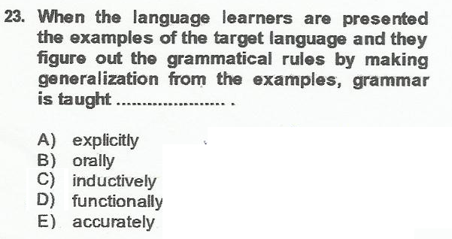

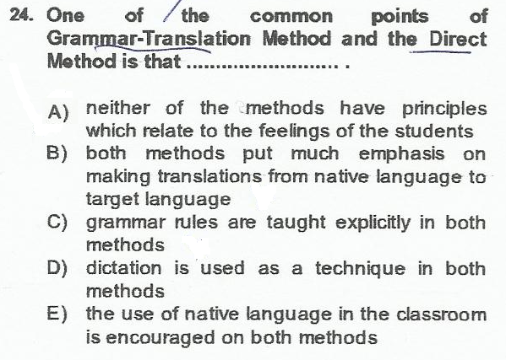

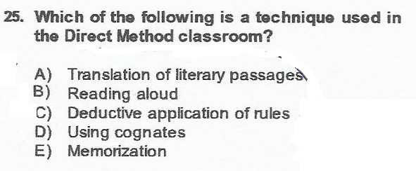

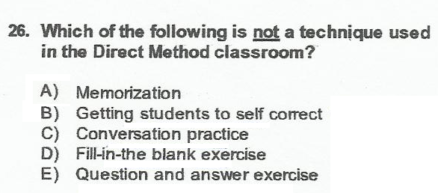

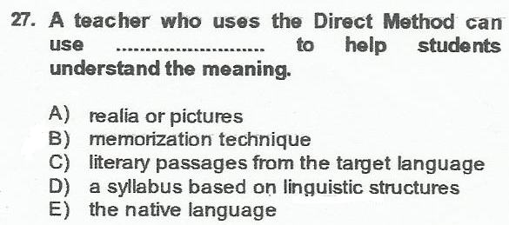

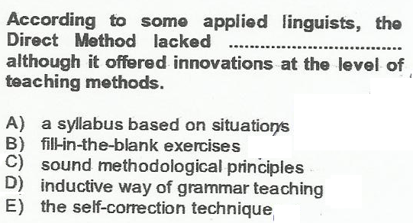

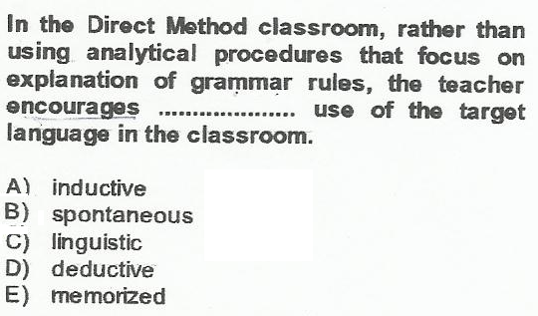

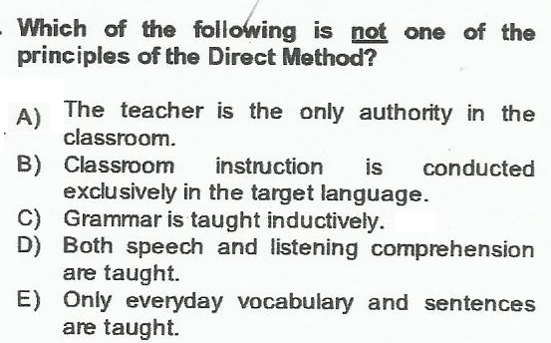

The Audio Lingual Method

**Memorization , dialogs and conditioning are the concepts which are related to Audio Lingual M.

**Which one is not a technique used in Audio Lingual M. ?
a ) Dialog completion b ) Chain drill c ) Using minimal pairs
d ) Repetition e ) Using cognates
**In Audio Lingual M language forms do not occur by themselves ;they occur most naturally within a context.
**In Audio Lingual M the teacher uses only the target language .Actions , pictures or realia are used to give meaning. = The native lang and the target lang have separate linguistic systems.They should be kept apart (ayrı tutmak ) so the students’ native lang interferes (karışmak , çatışmak) as little as with the target lang.
**In Audio Lingual M language teacher’s major role is that of a model in the target lang.
**In Audio Lingual M language learning is a process of habit formation.The more often something is repeated , the stronger the habit.
**In Audio Lingual M It’s important to prevent learners from making errors. Errors lead to the formation of bad habits.
**In Audio Lingual M the teacher says ‘very good ‘ when students answer correctly = Positive reinforcement help students to develop correct habits.
**In Audio Lingual M the teacher uses spoken cues and picture cues = Students should learn to respond to both verbal and nonverbal stimuli (uyarıcı )
**In Audio Lingual M the teacher conducts transformation and question and answer drills.= Each language has a finite patterns .Pattern practice helps students to form habits .
**In Audio Lingual M students should overlearn , learn to answer automatically without stopping to think.
**In Audio Lingual M the teachers should be an orchestra leader , conducting , guiding and controlling the students behaviour in the target lan.
**In Audio Lingual M the major aim of language teaching should be for students to acquire the structural patterns.
**In Audio Lingual M grammatical points are taught through examples and drills. = The learning of a foreign language should be the same as the acquisition of the native lang. We don’t need to memorize rules in order to use native lang.
**In Audio Lingual M the teacher does a contrastive analysis of the target language and the students’s native language in order to locate where her students will have trouble.= It’s important to overcome the habits of native language.
**The supermarket alphabet game and a discussion of American supermarket =Language is not only literature and fine arts , but also everyday behaviour of people who use the target language.
**In Audio Lingual M it’s important that students need to overlearn the target language , to learn it automatically without stopping to it.
The Techniques used The Audio Lingual Method
1 ) Dialog memorization 6 ) Transformation drill
2 ) Backward build up drill 7 ) Question and answer drill
3 ) Repetition drill 8 ) Use of minimal pairs
4 ) Chain drill 9 ) Complete the dialog
5 ) Single and multiple slot substitution 10) Grammar game
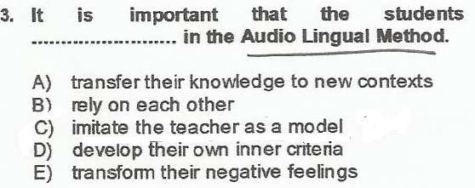

THE SILENT WAY
**The teacher points five blocks of colour without saying anything. The blocks of colour represent
the sounds of five English vowels close to the five simple vowels of Portuguese.

The teacher should start with something the students already know and build from that to the unknown. Languages share a number of features , sounds being the most.

**The teacher does not model the new sounds , but rather uses gestures to show how to modify the
Portuguese sounds.
Language is not learned by repeating after a model. Students need to develop their own ‘inner
criteria , to be responsible for their own production in the target language.

**Students take turns tapping out the sounds.
Student’s actions can tell the teacher whether or not they have learned.

** Students should learn to rely on each other and themselves.

** The teacher works with gestures and sometimes instructions with native language , to help students to produce the target language as accurately as possible.

** The teacher points to a rod and then to three blocks of color on the sound colour chart. The
students respond ‘rod’.
** Learning involves transferring what one knows to new contexts.

**The teacher sits down at the table and is silent.After a minute a girl points to a rod and says ‘a rod’

** Silence is a tool.It helps to foster autonomy , or the exercise of initiative It also removes the teacher from the center of attention.The teacher speaks , but only when necessary.

Meaning is made clear by focusing student’s perceptions , not through translation.

**One student tries to say ‘a pink rod’ and has trouble. He looks to the teacher , but the teacher is silent and looks to the other students.
** Student can learn from one another. The teacher’s silence encourages group cooperation.

**When a student has trouble pronouncing part of a phrase , the teacher helps using gestures.
** Errors are important and necessary to learning. They show the teacher where things are unclear.
**After locating the error for the student , the teacher does not supply the correct language until all
self -correction options have failed.

**The syllabus is composed of linguistic structures.

**Students should be able to use the language for self –expression – to express their thought , perceptions and feelings. In order to this , they need to develop independence from the teacher , to develop their own inner criteria for correctness.
**The role of teacher is a technician or engineer.
** THE TECHNIQUES ARE USED IN SILENT WAY.
**Sound –colour chart. ** Word chart

**The teacher’s silence ** Fidel charts

**Peer correction ** Structured feedback

**Rods

**Self-correction gestures
4 )In Silent way , the language learning and teaching process involves ………………………….
a ) repeating the newly learned structures
b ) trusting what the teacher says
c ) activating the material via dramatization
d ) transferring what one knows to new contexts.

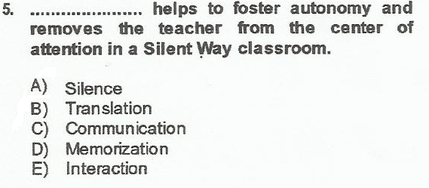

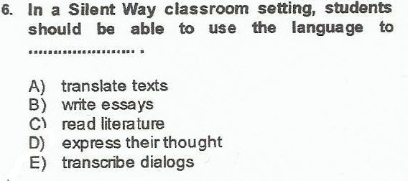

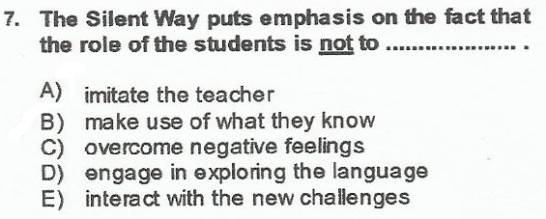

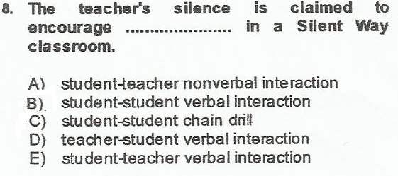

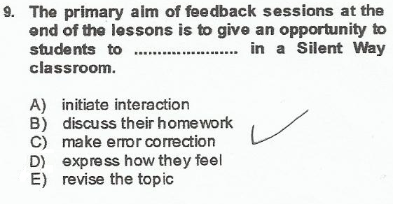

DESUGGESTOPEDIA
Desuggestopedia : the application of the study of suggestion to pedagogy , has been developed to help students eliminate the feeling that they cannot be successful , to help them overcome the barriers to learning.
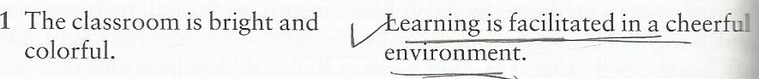

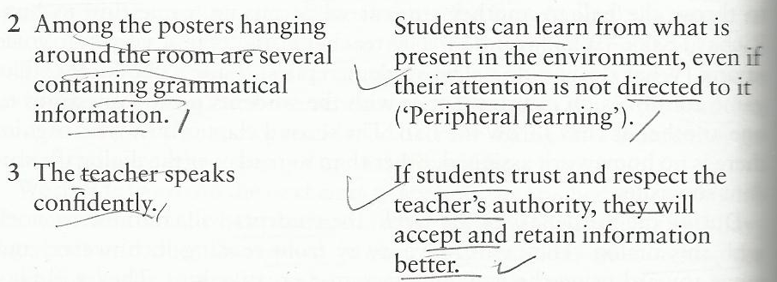

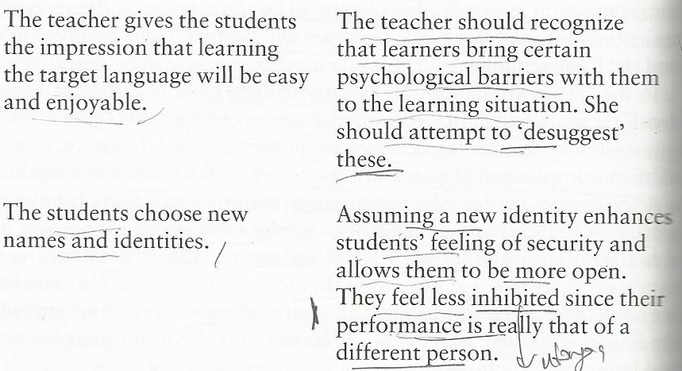

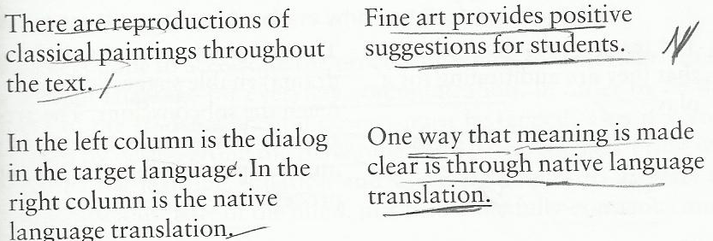
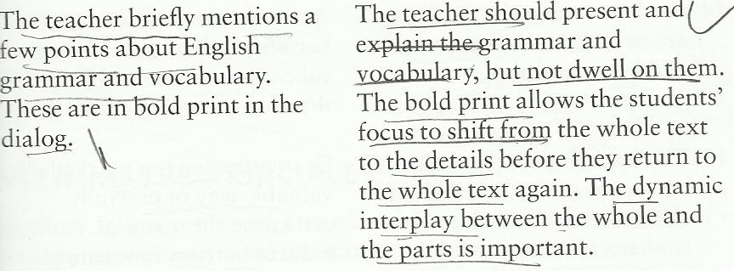
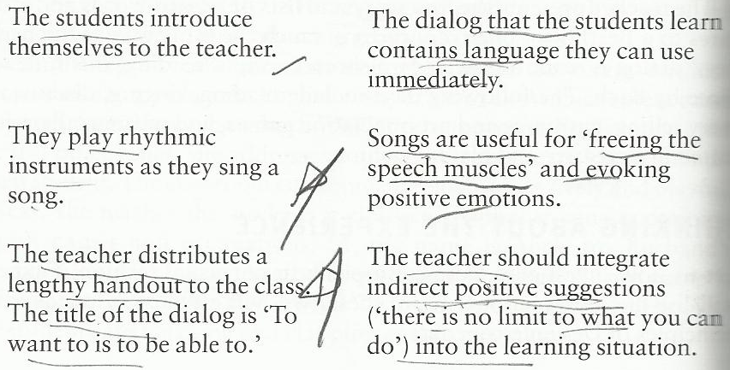

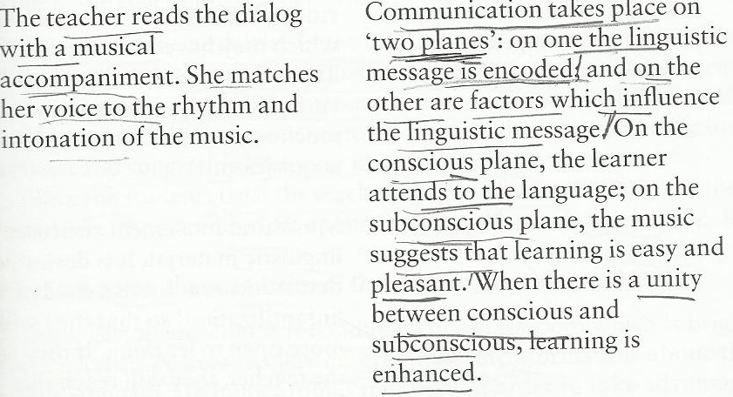

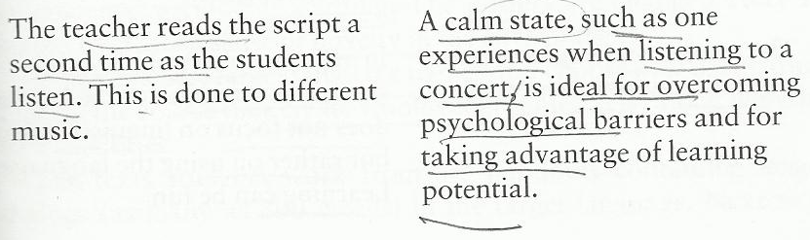

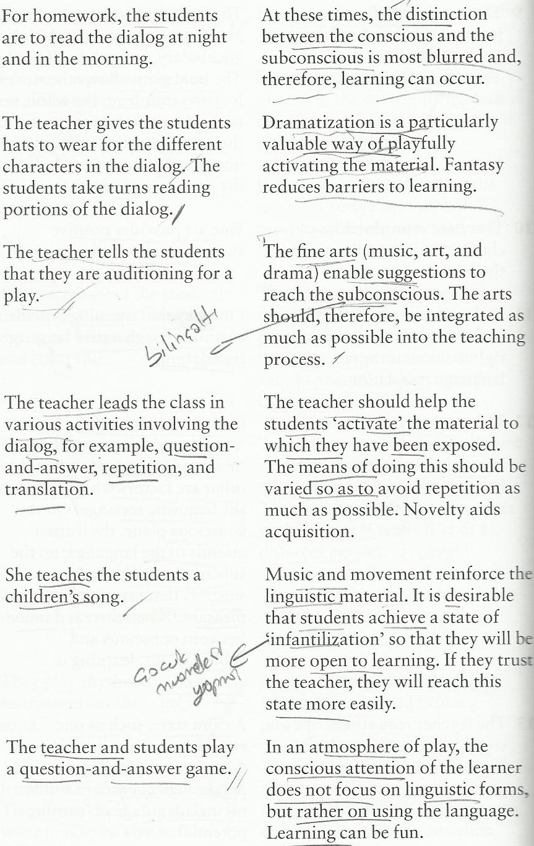

Errors are corrected gently , not in direct , confrontational manner.

The students need to learn to use a foreign language for everyday communication.

