

**Education: Vocabulary Quiz!!**

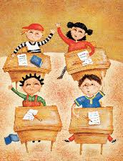

Children who study at school are:

The place or class to prepare children aged five for school:

A small white or coloured stick for writing on the board:

a. asylum

b. childhood

c. kindergarten

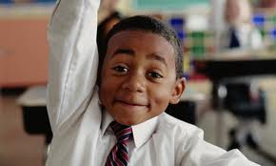

a. puppets

b. pupils

c. puppies

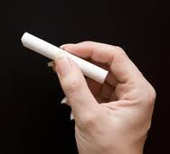

a. crayon

b. plaster

c. chalk

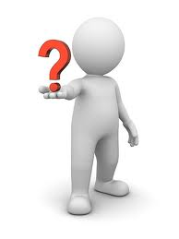

A school where children can live during the school year:

The place in a school where food and drink are served:

A book that contains the list of students’ names:



a. boarding school

b. night school

c. schoolyard

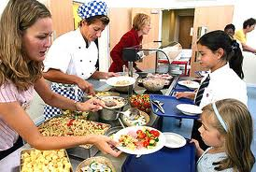

a. account book

b. school book

c. school register

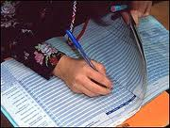

a. canteen

b. dining room

c. buffet

An area of knowledge studied in a school or college, e.g. biology, maths, etc.:

Exams that UK secondary pupils take in their final year of school:

Copying from books, notes or another student’s paper during a test or exam:

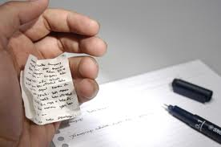

a. cheering

b. cheating

c. chatting

a. matter

b. subject

c. topic

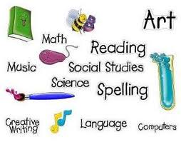



a. A-levels

b. High levels

c. National levels

When you do not pass a test or exam you…:

A University teacher is called:

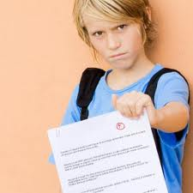

An instrument with two long thin parts joined together used for drawing circles:

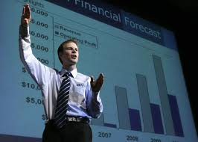

a. headmaster

b. professor

c. educator

a. fail

b. faint

c. fall

a. compressor

b. circumlocution

c. compass

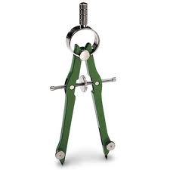

The person who is in the same class as you at school or college:

A test which is designed to find the appropriate level for students in a course:

A talk given to teach students a particular subject, often as part of a university course:

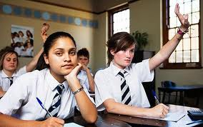

a. scholar

b. companion

c. classmate



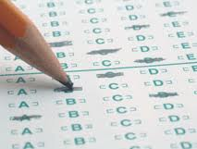

a. IQ test

b. placement test

c. blood test

a. lecture

b. lesson

c. class

A teacher who is in charge of a school:

An object shaped like a ball with a map of the world on its surface:

A long loose piece of clothing children wear over their clothes to protect them from dirt:

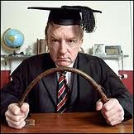

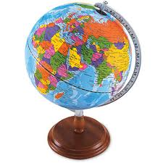

a. headman

b. headmaster

c. headhunter

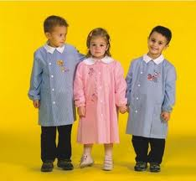

a. school cloak

b. school smock

c. school cape

a. glove

b. globule

c. globe

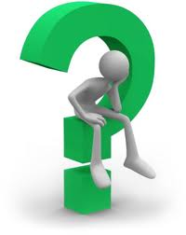

How do you call the subject in which students learn to cook or other skills needed at home?

How do you call the special set of clothes worn by children in some schools?



What’s the name of the list which shows the times at which subjects are taught at school?







How do you call the subject in which you study about electronic equipment, especially computers?

How do you call a department or group of related departments in a college or university?



What’s the word that means “the qualifications obtained by students who successfully complete a university or college course”?





What’s the name of the short period of time between lessons during which students can relax or eat some snacks?

How do you call all the teachers employed in a school?



What’s the word which means “one of the 3 periods in the year during which classes are held in schools, universities, etc.”?

__________________________________________________________________________________________________________

**ANSWERS**

1. Children who study at school are: **PUPILS**
2. The place or class to prepare children aged 5 for school: **KINDERGARTEN**
3. A small white or coloured stick for writing on the board: **CHALK**
4. A book that contains the list of students’ names: **SCHOOL REGISTER**
5. The place in a school where food and drink are served: **CANTEEN**
6. A school where children can live during the school year: **BOARDING SCHOOL**
7. Exams that UK secondary pupils take in their final year of school: **A-LEVELS**
8. An area of knowledge studied in a school or college, e.g. biology, maths, etc. : **SUBJECT**
9. Copying from books, notes or another student’s paper during a test or exam: **CHEATING**
10. A University teacher is called: **PROFESSOR**
11. When you do not pass a test or exam you…: **FAIL**
12. An instrument with two long thin parts joined together used for drawing circles: **COMPASS ( OR COMPASSES)**
13. A test which is designed to find the appropriate level for students in a course: **PLACEMENT TEST**
14. A talk given to teach students a particular subject, often as part of a university course: **LECTURE**
15. The person who is in the same class as you at school or college: **CLASSMATE**
16. A long loose piece of clothing children wear over their clothes to protect them from dirt: **SCHOOL SMOCK**
17. An object shaped like a ball with a map of the world on its surface: **GLOBE**
18. A teacher who is in charge of a school: **HEADMASTER**
19. How do you call the special set of clothes worn by children in some schools?: **UNIFORM**
20. What’s the name of the list which shows the times at which subjects are taught at school?: **SCHOOL TIMETABLE**
21. How do you call the subject in which students learn to cook or other skills needed at home?: **HOME ECONOMICS**
22. What’s the word that means “the qualifications obtained by students who successfully complete a university or college course”?: **DEGREE**
23. How do you call a department or group of related departments in a college or university?: **FACULTY**
24. How do you call the subject in which you study about electronic equipment, especially computers?: **IT (INFORMATION TECHNOLOGY)**
25. What’s the name of the short period of time between lessons during which students can relax or eat some snacks?: **BREAK**
26. What’s the word which means “one of the 3 periods in the year during which classes are held in schools, universities, etc.”?: **TERM**
27. How do you call all the teachers employed in a school?: **TEACHING STAFF**