DIRECTIONS  Fill in the blanks with  Should (advice, prediction)  Would (past, request, or conditional) or  Could (past, possibility, be able to) | 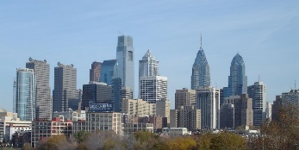  If you visit New  York City, you  s____________ come to Philadelphia, too. | 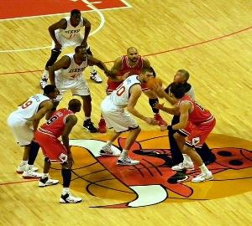  The 76ers s_________ win the basketball game.  Mixed Modals | 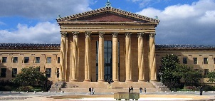  The Philadelphia Art Museum steps  w____________ not be famous  without Rocky.
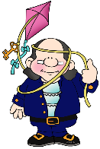  If not for Ben-  jamin  Franklin,  we  w___________  not have the University of Pennsylvania. | 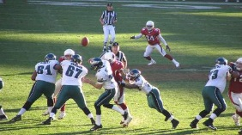  The Eagles football team c________  not beat the Broncos this year. | 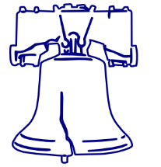  They_c_______ not fix the crack in the Liberty Bell. | 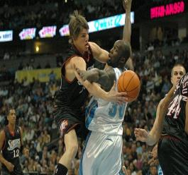  S_____________ we  call it a foul?
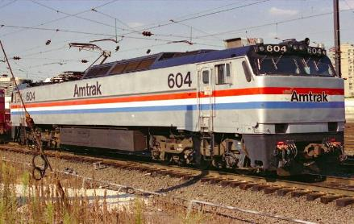  We c___________ take the train to save time. | 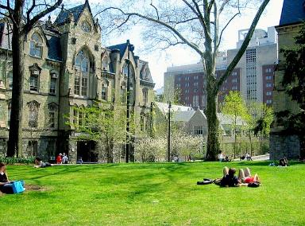  If tuition were cheaper, more students c_______  go to the University  of Pennsylvania. | 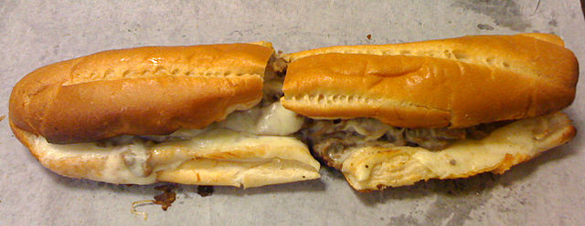  If you eat a cheese steak, you s___________ get it from Gino’s, and it is so big, you c__________  skip supper. | 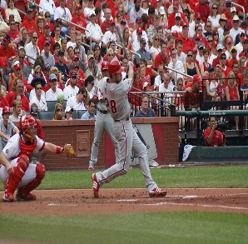  The Phillies w__________ win more ball games if they didn’t foul.
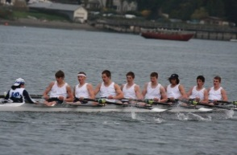  You s__________ be in good shape to compete in the Regatta Races. | 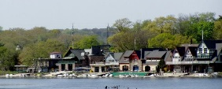  Our trip  w___________ not be complete without a visit to Boat House Row. | 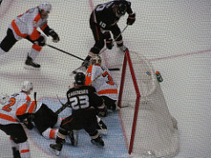  The Flyers hockey team c__________ have won if they went into overtime. | 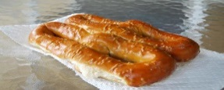  You s____________  try a Pretzel if you visit Philadelphia. You s____________ buy it at Reading Terminal Market.

Bibliography
All photos are in the public domain except the following
1st row 3rd photo: Basketball"20071127 Andre Iguodala cropped" by flickr user compujeramey - cropped from http://www.flickr.com/photos/compujeramey/2078800601/. Licensed under Creative Commons Attribution 2.0 via Wikimedia Commons - http://commons.wikimedia.org/wiki/File:20071127_Andre_Iguodala_cropped.jpg#mediaviewer/File:20071127_Andre_Iguodala_cropped.jpg
2nd row 1st photo: Philip Martin clipart http://inventors.phillipmartin.info/inventors_franklin.htm
2nd row 2nd photo: Eagles, by MPR529 (Flickr) 2005, Attribution-NonCommercial-NoDerivs 2.0 Generic (CC BY-NC-ND 2.0) http://goo.gl/ozgjht
2nd row 4th picture: 76ers, "Kyle Korver vs Reggie Evans" by Arthur Mouratidis - originally posted to Flickr as bball5 copy.jpg. Licensed under CC BY 2.0 via Wikimedia Commons - http://commons.wikimedia.org/wiki/File:Kyle_Korver_vs_Reggie_Evans.jpg#/media/File:Kyle_Korver_vs_Reggie_Evans.jpg
3rd row 2nd photo: "Collegegreen" by Bryan Y.W. Shin at the English language Wikipedia. Licensed under CC BY-SA 3.0 via Wikimedia Commons - http://commons.wikimedia.org/wiki/File:Collegegreen.jpg#/media/File:Collegegreen.jpg
3rd row 3rd photo: "Cheesesteak3" by SexyKick - Own work. Licensed under CC BY-SA 3.0 via Wikimedia Commons - http://commons.wikimedia.org/wiki/File:Cheesesteak3.jpg#/media/File:Cheesesteak3.jpg
3rd row 4th photo: Phillies,"Werth" by User shgmom56 on Flickr - From Flickr; description page is (was) here. Licensed under Creative Commons Attribution-Share Alike 2.0 via Wikimedia Commons - http://commons.wikimedia.org/wiki/File:Werth.jpg#mediaviewer/File:Werth.jpg
4th row 2nd photo: "Boathouse Row-wide" by Jeffrey M. Vinocur - Own work. Licensed under CC BY 2.5 via Wikimedia Commons - http://commons.wikimedia.org/wiki/File:Boathouse_Row-wide.JPG#/media/File:Boathouse_Row-wide.JPG
4th row 3rd photo: PHI VS ANA 363 by Dinur Flickr https://goo.gl/M8kYdT (CC BY-NC-ND 2.0)
4th row 4th photo: Pretael photo by slgckgc https://www.flickr.com/photos/slgc/5093610478 (CC BY 2.0)

