Picture Analyses 2
True or False
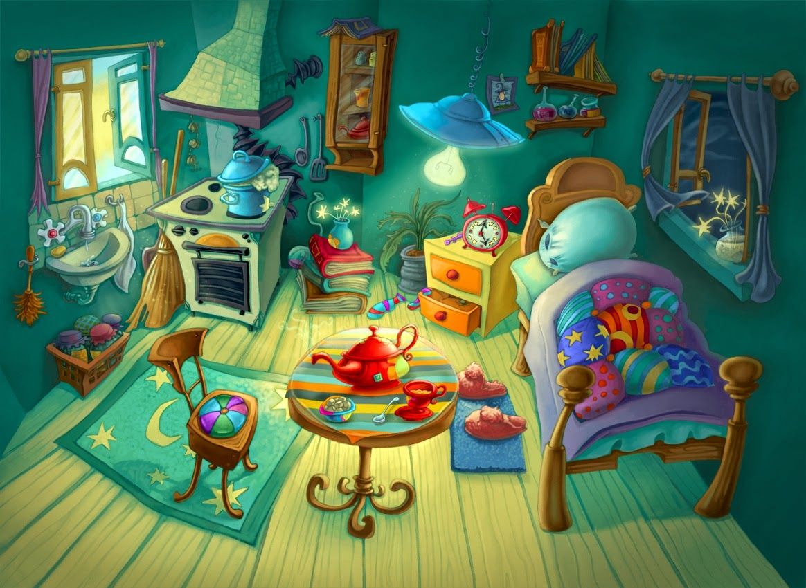

Look at the picture very well & then read the sentences below. Are they true or false? Correct the false ones.
1. There is a clock on the wall. | TRUE | FALSE
2. The window is above the bed. | TRUE | FALSE
3. The slippers are in the rug. | TRUE | FALSE
4. The pillow is on the bed. | TRUE | FALSE
5. The broom is behind the cooker. | TRUE | FALSE
6. The vase is on the books. | TRUE | FALSE
7. The jars are in a box. | TRUE | FALSE
8. The chest of drawers are next to the bed. | TRUE | FALSE
9. The pile of books are between the cooker & drawers. | TRUE | FALSE
10. The teapot is under the table. | TRUE | FALSE

