Picture Analyses
True or False
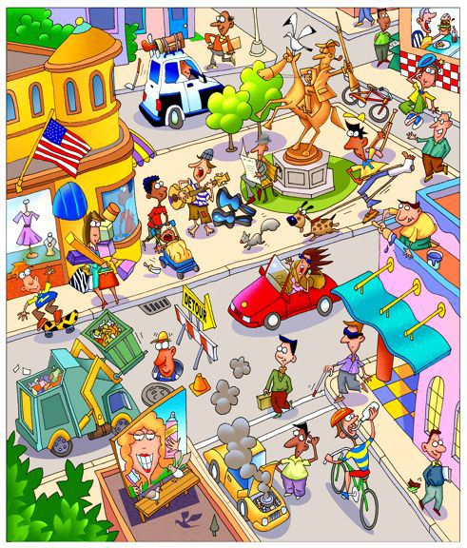

Look at the picture very well & then read the sentences below. Are they true or false? Correct the false ones.
1. This picture takes place in Europe. | TRUE | FALSE
2. It is a beautiful summer’s day. | TRUE | FALSE
3. The rubbish isn’t being collected today. | TRUE | FALSE
4. A baby is crying in its mother’s arms. | TRUE | FALSE
5. Children can use their skateboard on the road. | TRUE | FALSE
6. A woman has bought a lot of shopping. | TRUE | FALSE
7. There aren’t any restaurants in this part of town. | TRUE | FALSE
8. A man is busy painting his shop red. | TRUE | FALSE
9. Someone is helping a blind man cross the road. | TRUE | FALSE
10. A man with a broken arm is taking his dog for a walk. | TRUE | FALSE

