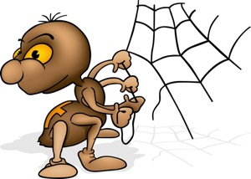
Picture Analyses 3
True or False
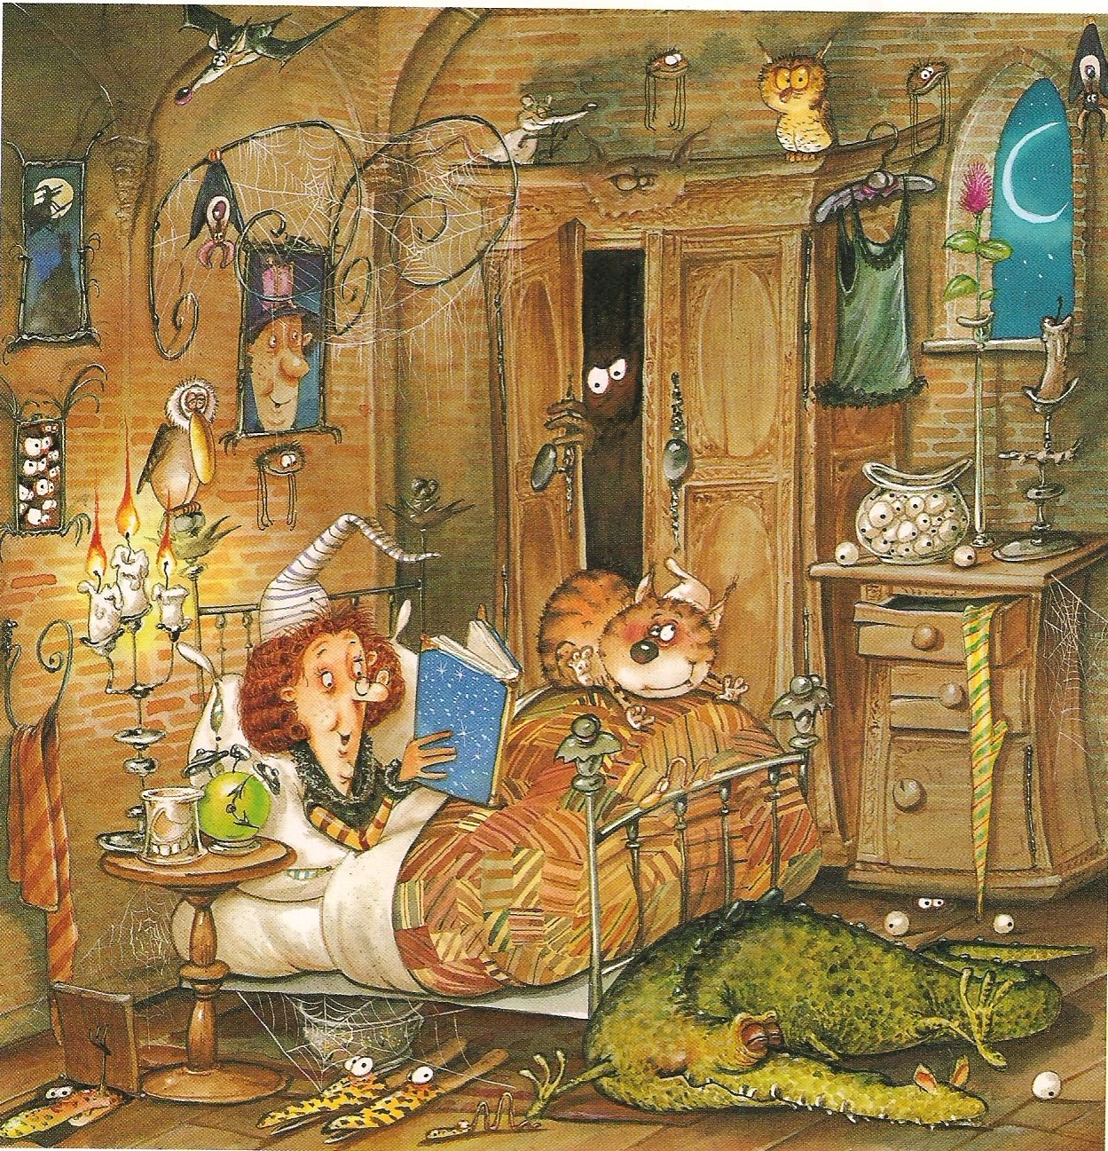

This is Maggie the witch. Examine the picture very well before deciding if the sentences below are true of false.
1.There are three candles in Maggie’s bedroom. | TRUE | FALSE
2. It is early morning and the sun is shining. | TRUE | FALSE
3. A snake lives under the floorboards. | TRUE | FALSE
4. A small slim cat sleeps on her bed. | TRUE | FALSE
5. There are three pictures on the wall. | TRUE | FALSE
6. The room is full of cobwebs. | TRUE | FALSE
7. She doesn’t wear glasses. | TRUE | FALSE
8. Even though she is a witch, Maggie has a kind face. | TRUE | FALSE
9. She likes owls. | TRUE | FALSE
10. Maggie wears strange looking slippers. | TRUE | FALSE

