 | Peter _________ (play) football at the moment. |  | Lucky is Tim’s dog, so the dog is _______. | Miss Chan is shouting at Paul _______ (angry/angrily) because he did not hand in the homework. |  | Justin Bieber is ___ famous singer.
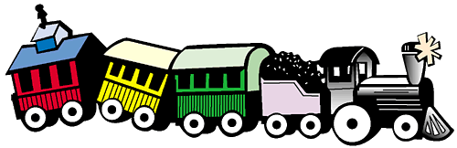 |  |  |  |  |  | Yesterday, I _______ (not go) to school.
I dropped my book on the floor of____ MTR yesterday. | Is this your book?  Yes, this book is ________. |  | Suzy usually ______ (watch) TV after school. | I bought a new toy yesterday. ____ toy is a paper airplane. |  | Uncle Bob is so fun, we all like ____.
My friends _________ (dance) in the classroom now. They look so funny!
I am so _______ (lucky/luckily) to have so many good friends in my life. | I burned my finger yesterday, but I _________ (feel) so much better now. | The book was fun, but I hate ____ now because I need to do a book report about it. |  | The movie ‘Twilight’ was not _______ (scared/ scary) at all! | Please give me ____ apple on that table.
Tense = 4 points Parts of Speech = 3 points  Pronouns = 2 points Articles (A/ An/ The) = 1 point  Extra (2) points the first that reaches Finish  (You must READ OUT THE WHOLE SENTENCE.) |  |  |  |  | When Miss Chan is sick, she needs to go to ____ doctor.
 | Dogs need____ own space. | Last winter, we made ___ snowman. |  | Water ______ (turn) to ice when it is too cold. | I felt _____ (tried/ tired) after such a long day!
Game Rules:
- Place your counters on Start and throw the dice.
- Player with the highest number begins the game.
- Depending on the square you land on, you have to answer the questions.
- If the answer is correct, you can stay on the square.
- If you were wrong, you have to go back to the square you were before.
- The one with the highest points wins.
Point system:
Tense = 4 points
Parts of Speech = 3 points
Pronouns = 2 points
Articles (A/ An/ The) = 1 point
Extra (2) points the first that reaches Finish
(Use the markers to write the points you got on the score card.)

