PRESENT SIMPLE OF “BE” – POSSESSIVE ADJECTIVES
Exercise 1: Complete the sentences with the correct form of “be”:

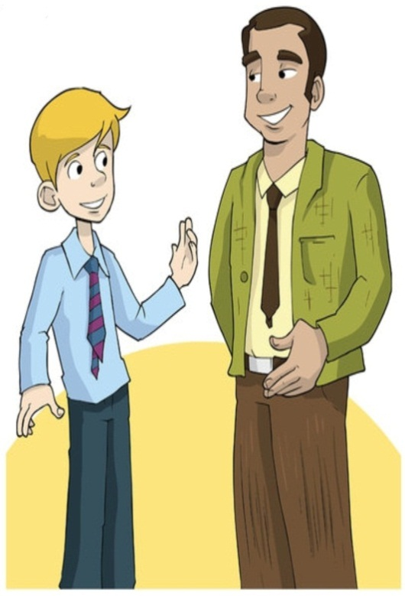
Mr.Red: Hello. I’m Mr.Red._Are__you Green?
Green: Yes, I______. Hello, Mr.Red. ________I in your class?
Mr.Red: No, you_______. You_______in class A.
Green: ______that Mrs.Yellow’s class?
Mr.Red Yes,that_____.
Green: _____Toby in her class too?
Mr.Red No,he______. He_____in my class. _____he your friend?
Green: Yes, he_____. _______Jack and Emma in class A?
Mr.Red: Yes, they_______.
Green: Good. They______my friends too.

Exercise 2: Write questions:
John: Hello. I’m John.¹_____________________________________________?
Beth: My name is Beth.
John: ²_________________________________________________?
Beth: I’m twenty-two years old .
John: ³__________________________________________________?
Beth: I’m from Manchester, England. ⁴__________________________________?
John: No, I’m not. I’m from London.
Beth: ⁵___________________________________________________?
John: I’m a doctor.
Beth: ⁶___________________________________________________?
John: My favourite sport is basketball.
Beth: ⁷___________________________________________________?
John: Yes, I can. I go swimming on Sunday.
Beth: ⁸___________________________________________________?
John: No, I haven’t. I have got a puppy. I don’t like cats.
Exercise 3: Complete the sentences with possessive adjectives:
- James and Alice have got a cat. ___Their_______cat is grey.
- Edward and I have got bikes. ______________bikes are red.
- Frank has got two dogs. ________________dogs are old.
- I have got a computer. _________________computer is new.
- Kim and Martin have got books . ______________books are colorful.
- Amy has got jeans.______________jeans are blue.
- Billy has got a camera. ______________camera is expensive.
- My sister and I have got an English teacher. _____________teacher is good.
- You have got a mobile phone. _______________mobile phone is nice.
- Fred’s dog has got a bone. _____________bone is small.
- Those children have got a bedroom. _________bedroom is big.
- The rabbits have got carrots. ____________carrots are orange.

