EVERYTHING ABOUT ME
My first name is Edmond My last name is DURANG
My English nickname is My telephone number is
My date of birth is 22.04.1987
My parents' address is
I have brother(s) and sister(s)
I have one pet or more at home : □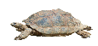a turtle □a rabbit
□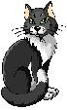a cat □a dog □a fish □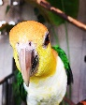a bird □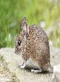a mouse
MY PHOTO □ a guinea-pig □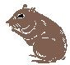a hamster □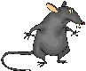a rat □ another animal
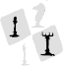My hobbies: are □ playing chess □ playing video-games □playing cards □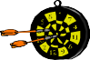 playing darts □cycling □jogging
~
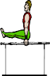
□s w i m m i n g □ playing football□ playing rugby □playing tennis □ playing ping-pong
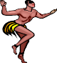
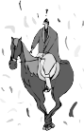
□playing basket-ball □playing volley-ball □playing handball □ gymnastics □ dancing
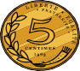
- listenin g t o music □read i n g □ watching television □ roller-skating □ h o r s e - r i d i n g
- ta k i n g pictures □ goi n g to the pictures □ playi n g music □ collecting stamps □ collecting coins □other
My favourite music style is□rap/hip hop/r'n'b □classical □pop/rock □ 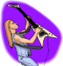hard rock/heavy metal □other
My favouri te acto r/ac t r e s s is: _____ _ _ _ _ _ _ _ My favouri te singer/b and is: _____ _ _ _ _ _ _ _
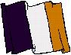
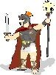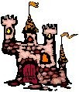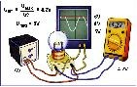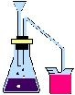Sch ool subjects I lov e=‚/I like =P/I don' t mind =Y/I don' t like =2/I hate =/I don' t know =?

_______________ Spa nish
_______________ German
_______________ French

_______________ Bi ology and Geology

_______________ M a t h s

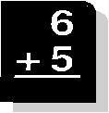
_______________Engl ish

_______________ L a t i n

_______________ Cra f ts

_______________I. T.

_______________ P.E.
_______________ Music
_______________ Art

_______________ History and Geography

_______________ Physi c s and Chemistry

