Film: Vantage Point

- Choose one of the following characters an take notes. Who is she/he, what
is he/she doing during the assassination attempt? Why is he/she important?

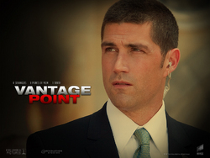
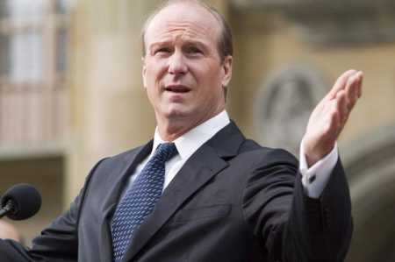
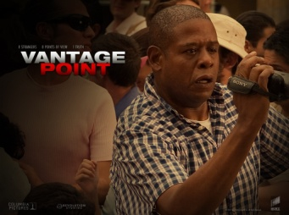
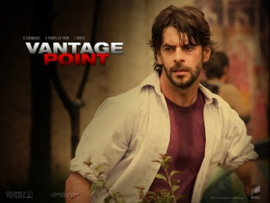
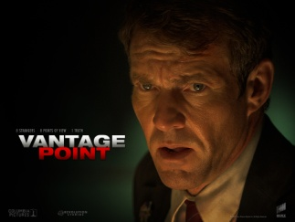
Kent Taylor
President Ashton
Thomas Barnes
Howard Lewis
Rex Brooks
Enrique

- Who are these people? What's their part in the film?

- President Ashton:

- Thomas Barnes:

- Kent Taylor

- Enrique:
Veronica & Javier

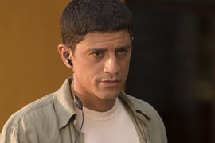
- Howard Lewis:
Suarez

- Who is actually the assassin?

- Why did Javier help the assassins?

- What do we learn about Kent Taylor?

- What's the name of the little girl? Why is she important?

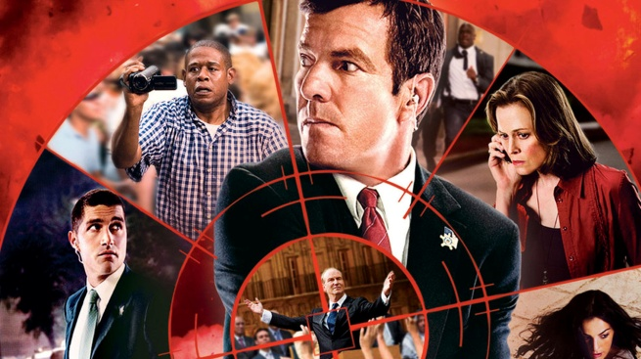
- What happened in reality?

