|  |  |  |  |  |  |
| --- | --- | --- | --- | --- | --- |
|  | Name | Food | Clothes | Animal | Sport |
| B |  |  |  |  |  |
| C |  |  |  |  |  |
| F |  |  |  |  |  |
| G |  |  |  |  |  |
| L |  |  |  |  |  |
| M |  |  |  |  |  |
| S |  |  |  |  |  |

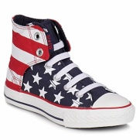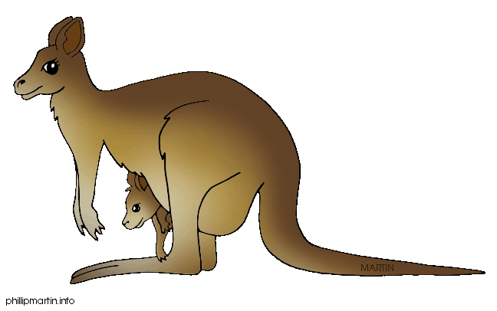**-write a word in each category; use the letter in the box.**

**Who is the first one to finish?**

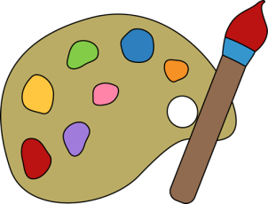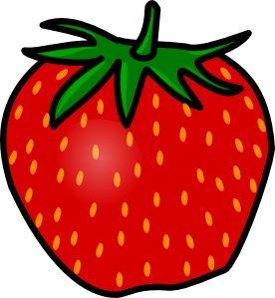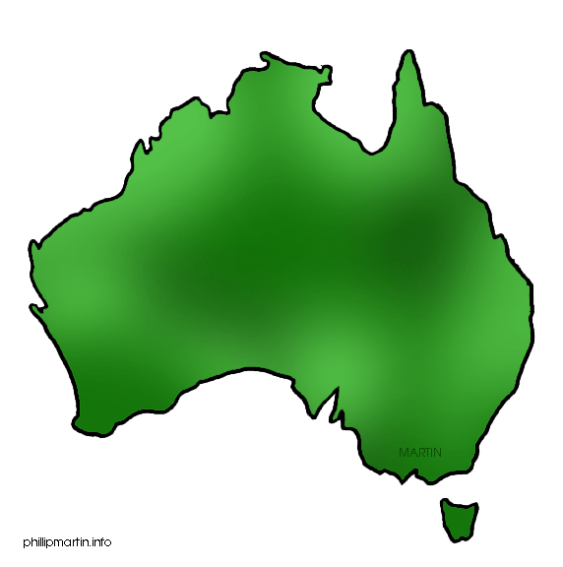

|  |  |  |  |  |  |
| --- | --- | --- | --- | --- | --- |
|  | Country | Fruit | Veggie | Colour | Vehicle |
| A |  |  |  |  |  |
| D |  |  |  |  |  |
| E |  |  |  |  |  |
| H |  |  |  |  |  |
| N |  |  |  |  |  |
| O |  |  |  |  |  |
| T |  |  |  |  |  |