

**Food & Eating Habits: Vocabulary Quiz!**[**www.eegitimim.com**](http://www.eegitimim.com/)

The piece of cloth or paper used at meals for cleaning your mouth:

Knives, forks and spoons together are called:

Small amounts of food served before the main course:

a. nappy

b. sheet

c. napkin

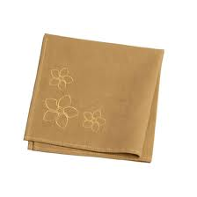

a. cattle

b. cutlery

c. castle

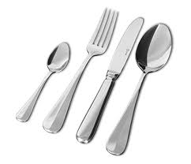

a. beginners

b. starters

c. premier

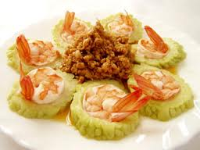

A liquid food often eaten as the first course of a meal:

The round yellow part in the middle of an egg is called:

A “trifle” is :

a. soap

b. sour

c. soup

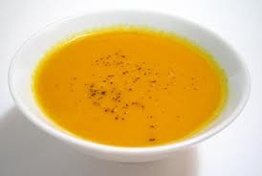

a. yo-yo

b. yogi

c. yolk

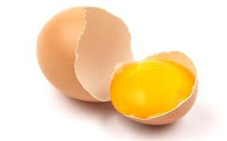

a. a rifle with 3 bullets

b. a mushroom

c. a cold dessert

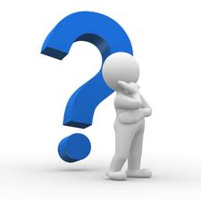

Meat which is not cooked at all is:

Something you eat between meals is:

A cold dessert made with cream and egg whites and flavoured with fruit or chocolate is:

a. row

b. rare

c. raw

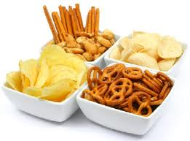

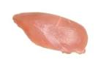

a. a snail

b. a snack

c. a snake

a. a mole

b. a mouse

c. a mousse

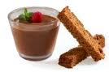



Food that is kept in the freezer is:

“Dairy products” are:

A thick slice of quality beef is:

a. a stick

b. a steak

c. a stock

a. freezing

b. frozen

c. fizzy

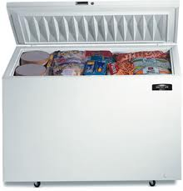

a. products you eat every day

b. products made from milk

c. organic products

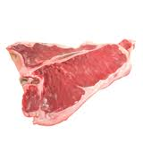

The thin sauce used to add flavour to salads is called:

The piece of paper that shows how much you owe the restaurant at the end of your meal is the:

Part of a cooker in which you can bake or roast food:

a. dressing

b. additive

c. custard



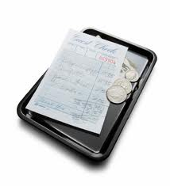

a. furnace

b. oven

c. incinerator

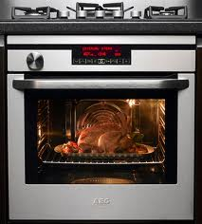

a. bill

b. account

c. receipt

A “vegan” is someone who:



The place in a school, company, etc. where food and drink are served is:

The person who makes the food in a restaurant is the:

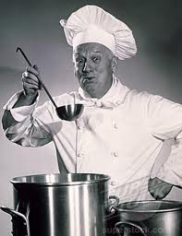

a. doesn’t eat vegetables

b. doesn’t eat meat

c. doesn’t eat any animal products

a. a buffet

b. a canteen

c. an inn

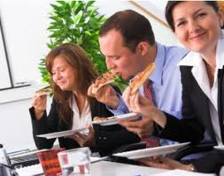

a. cook

b. cooker

c. cookie

What are the 3 parts in which an English menu is usually divided?

How do you call the food which is produced without artificial chemicals?

What type of food are peas, beans and lentils?

What’s the adjective that describes food made from brown flour?

What are the 3 main meals people usually have during the day?

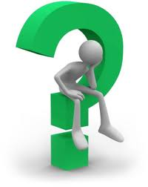



How do you call the food you buy from a restaurant to eat at home?









How do you call the amount of extra money you give to the waiter at the end of your meal?

How do you call water that does not contain bubbles or gas?





How do you call food that contains a very small amount of fat?



__________________________________________________________________________________________________________

**ANSWERS**

1. The piece of cloth or paper used at meals for cleaning your mouth: **NAPKIN**
2. Knives, forks and spoons together are called: **CUTLERY**
3. Small amounts of food served before the main course: **STARTERS**
4. A liquid food often eaten as the first course of a meal: **SOUP**
5. The round yellow part in the middle of an egg is called: **YOLK**
6. A “trifle” is**: A COLD DESSERT**
7. Meat which is not cooked at all is: **RAW**
8. Something you eat between meals is: **A SNACK**
9. A cold dessert made with cream and egg whites and flavoured with fruit or chocolate is: **A MOUSSE**
10. Food that is kept in the freezer is: **FROZEN**
11. “Dairy products” are: **PRODUCTS MADE FROM MILK**
12. A thick slice of quality beef is: **A STEAK**
13. The thin sauce used to add flavour to salads is called: **DRESSING**
14. The piece of paper that shows how much you owe the restaurant at the end of your meal is the: **BILL**
15. Part of a cooker in which you can bake or roast food: **OVEN**
16. The place in a school, company, etc. where food and drink are served is: **CANTEEN**
17. The person who makes the food in a restaurant is the: **COOK**
18. A “vegan” is someone who: **DOES NOT EAT ANY ANIMAL PRODUCTS**
19. The 3 parts in which an English menu is usually divided are: **STARTERS, MAIN COURSE, DESSERTS**
20. The food which is produced without artificial chemicals is: **ORGANIC FOOD**
21. Peas, beans and lentils are: **LEGUMES or PULSES**
22. The adjective that describes food made from brown flour is: **WHOLEMEAL**
23. The 3 main meals people usually have during the day are: **BREAKFAST, LUNCH, DINNER**
24. The food you buy from a restaurant to eat at home is: **TAKEAWAY FOOD**
25. Water that does not contain bubbles or gas is: **STILL WATER**
26. The amount of extra money you give to the waiter at the end of your meal is the: **TIP**
27. Food that contains a very small amount of fat is: **LOW-FAT FOOD**