BIST DU EIN ECHTER FREUND/EINE ECHTE FREUNDIN?

- Was sind die wichtigsten Qualitäten /Eigenschaften der Freundschaft, deiner Meinung nach?
Treue
Vertrauen
Hilfsbereitschaft
Ehrlichkeit
Liebe….
- _____________________________
- _____________________________
- _____________________________
- _____________________________
- _____________________________

- Was macht ein echter Freund?
____________________________________________________________________________________________________________________________________________________________________________________________________________________________________________________________
mit dir streiten
dir zu-hören
dich trösten
dir Mut machen
dich ab-lenken
seine/ihre Meinung sagen
Witze über dich machen
ehrlich sein
dich verstehen
Lüge erzählen – dich belügen
dir Tipps geben
dich akzeptieren, so wie du bist
Gefühle teilen
dir helfen
in… sich verlieben
sich auf die Nerven gehen
sich unterhalten
dir vertrauen
spontan sein
_______________________________________________________________________________________________________________________________________________________________________________________________________________________________________________________________________

- Was soll er/sie nie machen?
________________________________________________________________________________________________________________________________________________________________________________________________________________________________________________________________________
____________________________________________________________________________________________________________________________________________________________________________________________________________________________

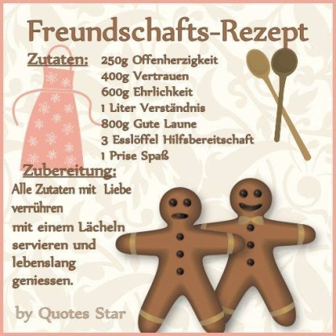
Ein Freund ist jemand, der/den/mit dem_______________
___________________________________________________________________________________________________________________________________________________________________________________________

