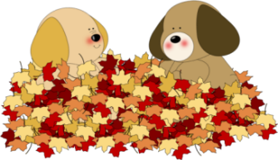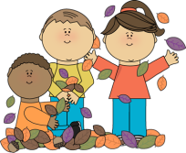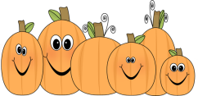

Which three things are not described in the text?

1. In autumn you collect apples in a basket for the winter season.

2. Three kids are playing in the autumn leaves.

3. Pilgrims came to America many years ago. They celebrated that they survived the first year in a new country.

4. Three colorful autumn leaves (purple, orange and green).

5. Autumn crops for Thanksgiving.

6. You see a lot of leaves and a rake.

7. A popular crop used for food and decorations. People carve them and put a candle inside.

8. Two dogs are playing in a big pile of leaves.

9. In October kids like to dress up for Halloween. They then go Trick or Treating.

10. A girl is standing in the middle of a pile of leaves holding a rake.

11. Three golden leaves.

12. A boy is pushing a wheelbarrow loaded with a heavy pumpkin.

13. The leaves are coming off the tree.

