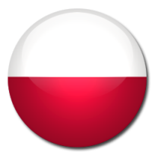

Which three countries/flags things are not described in the task?

1. People in this country eat a lot of spaghetti, pizzas and they drink a lot of wine.

2. The famous fairytale writer Hans Christian Andersen is from this country.

3. This country is the home country of Nelson Mandela.

4. You find kangaroos, koalas, dingoes and crocodiles in this country.

5. The Argentinean soccer player Messi plays in this country.

6. They have two official languages: English and French.

7. Fifty states make up this great nation.

8. This country is called the land of 1000 lakes.

9. They have four official languages in this mountain country. They are French, Italian, German and Romanish.

10. Lance Armstrong won a big cycle race seven times in this country. He has, however, lost the 7 titles and yellow jerseys.

11. The country borders to Finland.

12. Three countries make up Scandinavia: Denmark, Norway and ?

13. This country borders Spain and the Atlantic Ocean. The capital is Lisbon.

