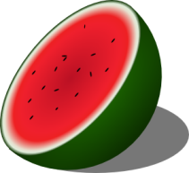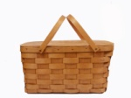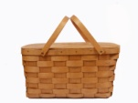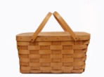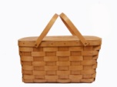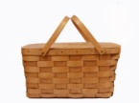

Which three picnic things are not described in the task?

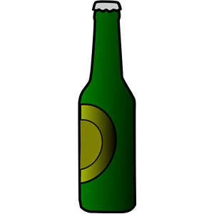 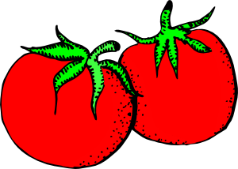  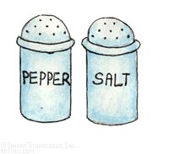  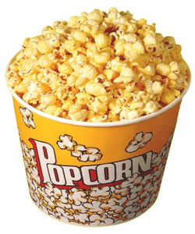

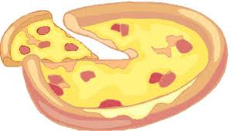 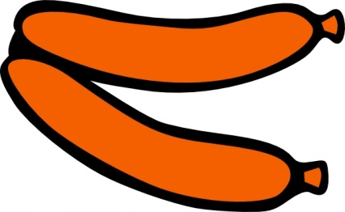 

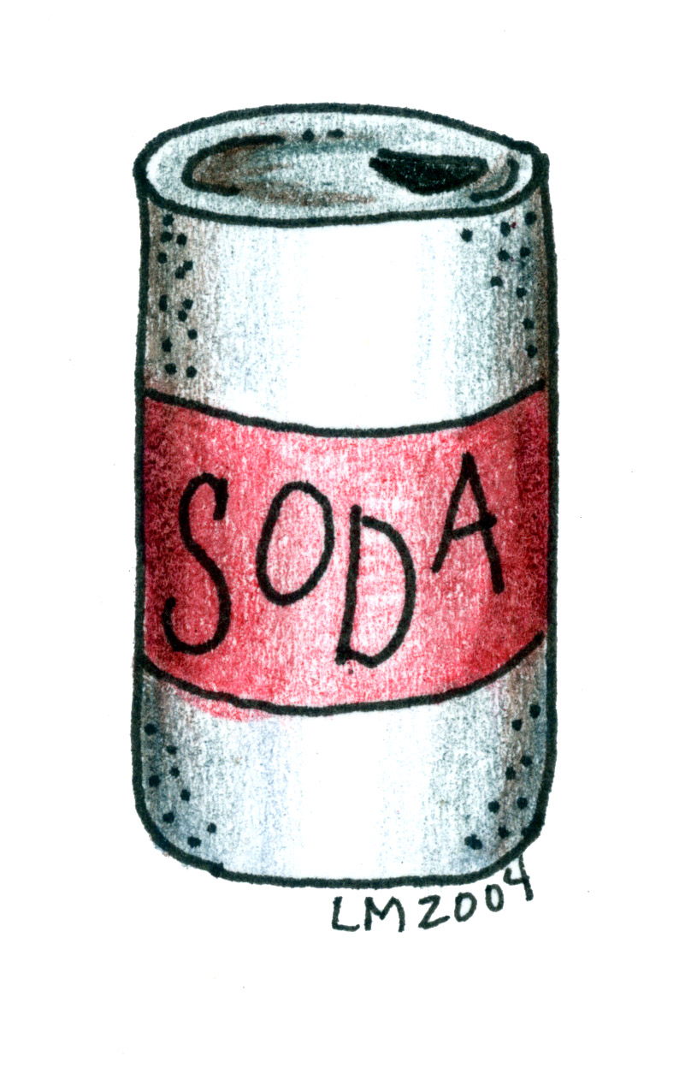  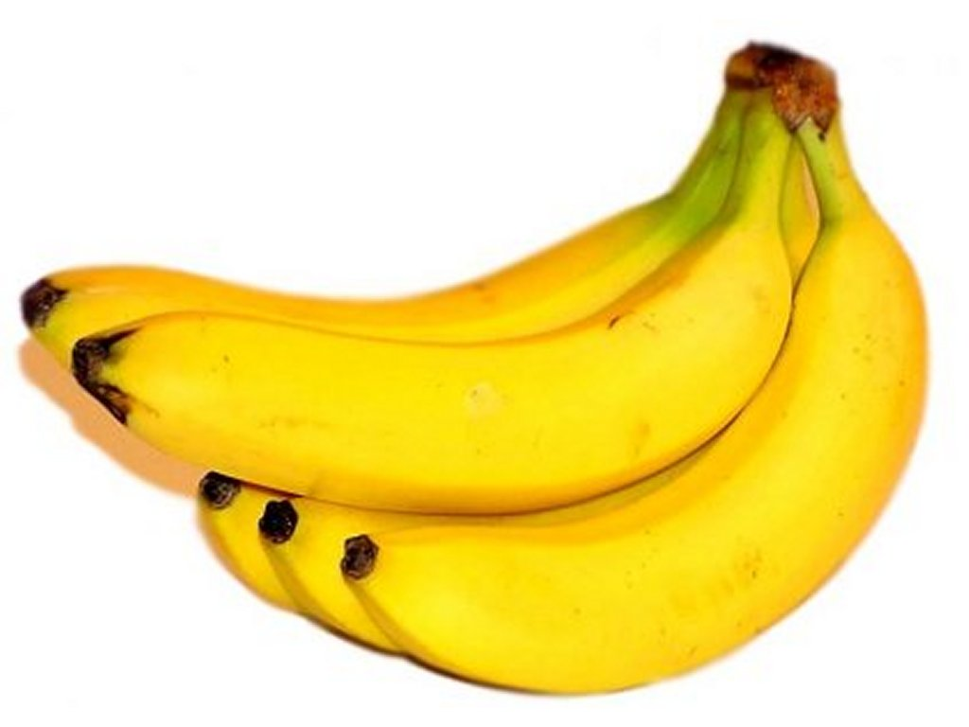 

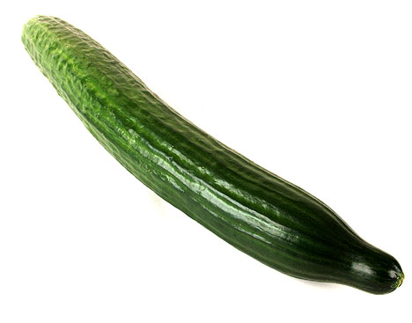 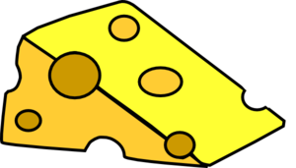 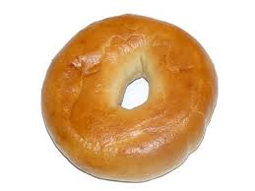 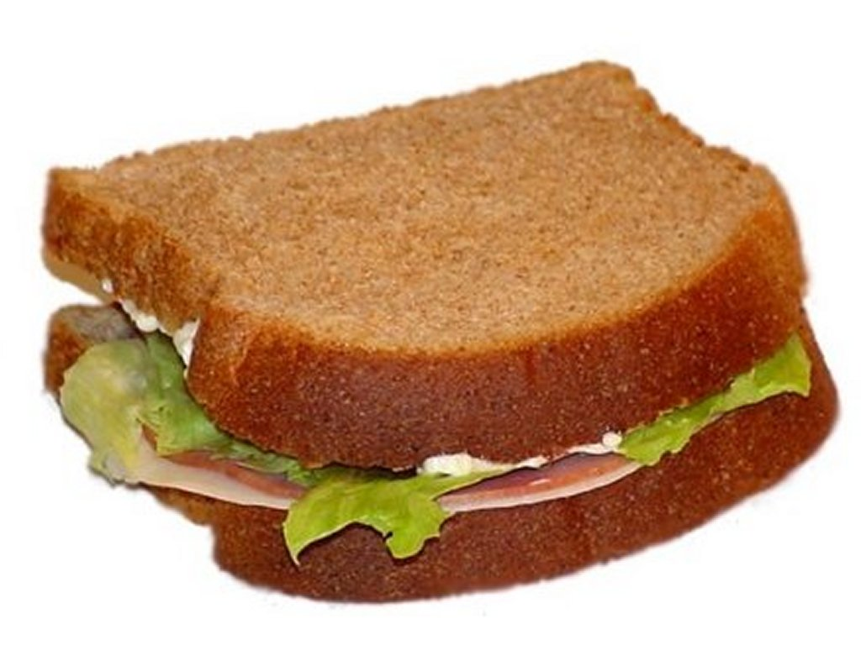 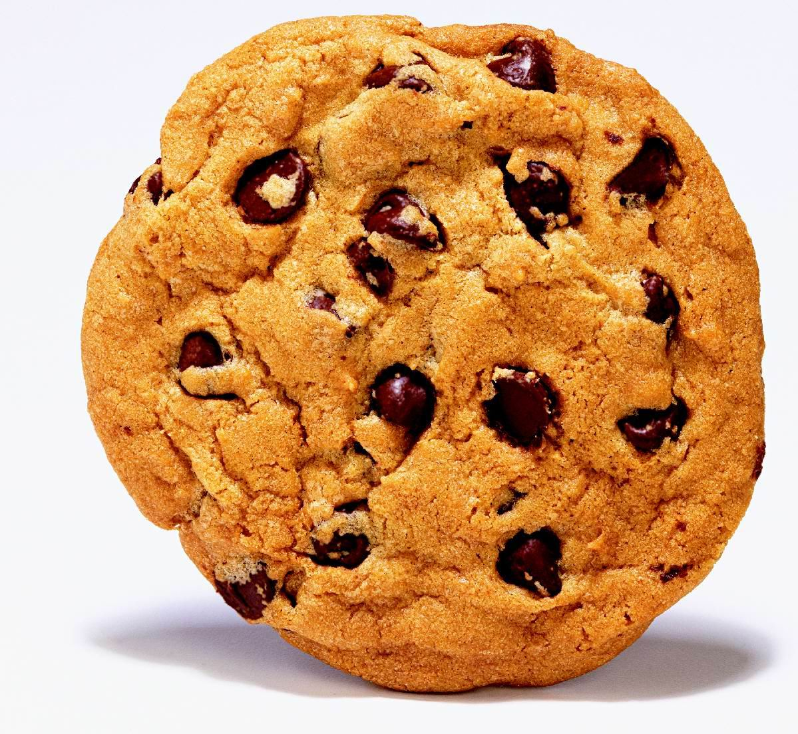  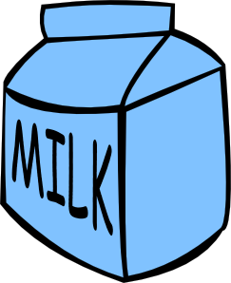

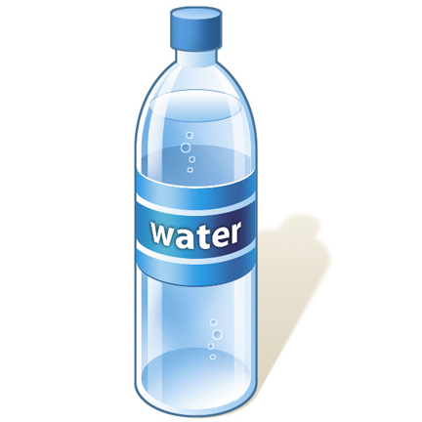  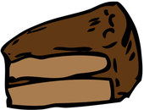

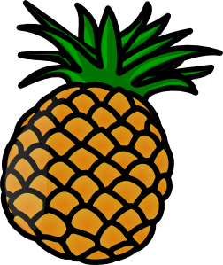

1. Many kids like this salty snack.
2. This food is originally from Italy. It has tomato sauce, sausages and cheese on it.
3. It is a kind of bun. It has a hole in the middle.
4. This food has chocolate chips in it! Yummy!!
5. You need to pieces of bread, some lettuce, ham and mayonnaise to make one.
6. “I come in a bottle and children should not drink me.”
7. There is a lot of water in it. You can slice it. When it is stored cold it is good on a hot day.
8. It is something eaten with a cup of tea or coffee. It is very rich. You may need a spoon or fork to eat it.
9. “Some people call me “pop”, others “soda”. Well, I come in a can.”
10. “I am yellow on the inside and brown on the outside. I have a green top”.
11. “We are red on the outside and red on the inside. You will find seeds inside.”
12. These two friends are what we call spices.
13. Every person should drink two liters every day of this product.
14. This is a popular eating of grown- ups, less popular with children.
15. Something made of meat from a pig, a cow, chicken or turkey. Sometimes eaten dipped in ketchup and mustard.