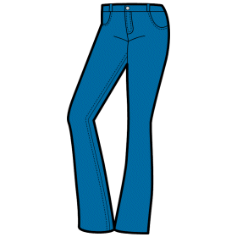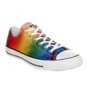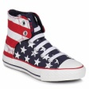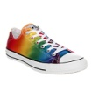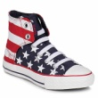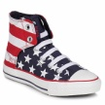

1. You wear this on your feet when it is summer.
2. Baseball players wear them on their heads.
3. A long “jacket”.
4. Only girls and women wear this piece of clothing on the top part of the body.
5. When it is cold they are nice to wear on your hands.
6. A cowboy wears these on his feet summer or winter.
7. Men wear this piece of clothing around their necks.
8. It is a long-sleeved piece of clothing and may be knitted.
9. They are blue and worn by all people.
10. This is a female shirt and is called a blouse.
11. It is a short coat.
12. Girls or women wear it and when they do you can see their legs.
13. Everybody has one and it comes in many colours and patterns. It is madde of cotton.

Which three picnic things are not described in the task?

