Toutes ses personnes ne sont pas très contentes avec leur situation actuelle. Imaginez ce qu'elles pensent faire dans l'avenir. Soyez créatif. Utilisez le futur simple.
2. Quand je retournerai à la maison...
3.Quand j’aurai mon permis de conduire...
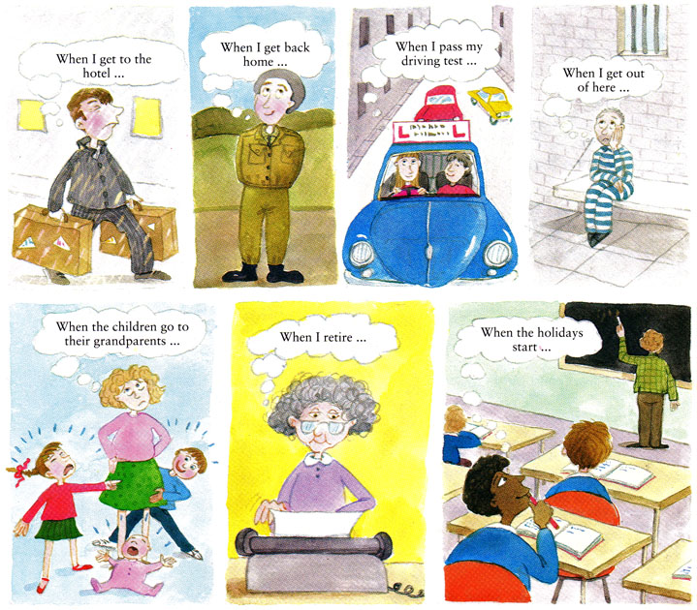
5.Quand les enfants iront chez les grand-parents...
7.Quand je serai en vacances...
1. Quand j’arriverai à l’hôtel, je....
4.Quand je serai en liberté...
6.Quand je serai en retraite...

1.____________________________________________________________________________
_____________________________________________________________________________
2.____________________________________________________________________________
_____________________________________________________________________________
3.____________________________________________________________________________
_____________________________________________________________________________
4.____________________________________________________________________________
_____________________________________________________________________________
5.____________________________________________________________________________
_____________________________________________________________________________
6.____________________________________________________________________________
_____________________________________________________________________________
7. ____________________________________________________________________________
______________________________________________________________________________

