PRESENT BE+ING – FUTURE PLANS

What are they doing next week? Make a sentence .
John | Monday morning - NEW-YORK IMPORTANT MEETING
Sarah and Peter | Next weekend Mediterranean sea / Visit Italy/ Spain / Morocco
Nadia | Tomorrow Paris / stay with her grandmother for a week
You and your friends | Tonight English test tomorrow
Your parents | Next week move to a new house next Saturday
You | Write your own sentence

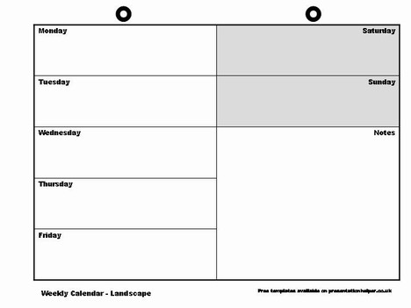
Now look at Johanna’s diary and make sentences to tell your teacher what she is doing next week
12.30 lunch with Sarah
9.00 important meeting at John’s office
13.00 Sarah / shopping
4 p.m hairdresser
7 pm Steven’s birthday party
5pm dentist

