***FUTURE PLANS: GOING TO***

**A) Look at Barry’s plans for the weekend and form sentences about what he’s going to do.**

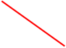

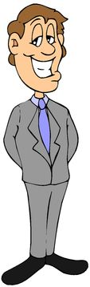 **1   
 2   
 3   
 4**

**5   
 6**

**B) Turn the sentences into the future (going to) Use future expressions we’ve seen in class**

a. We watch tv every morning **___________________________________________________________**

b. She reads the paper every day **____________________________________________________________**

c. Do you clean your bedroom every morning? **____________________________________________________________**

d. My sister doesn’t take the rubbish out every night **_____________________________________________________________**

e. Where does your father have lunch? **_____________________________________________________________**

f. She travels to USA with her boyfriend **_____________________________________________________________**

**C) Imagine you are a famous person (movie star, singer, sportsman/woman, etc.). Write about your job and about your future plans and future desires/ambitions.**

**_______________________________________________________________________**

**_______________________________________________________________________**

**_______________________________________________________________________**

**_______________________________________________________________________**

**_______________________________________________________________________**

**_______________________________________________________________________**

**_______________________________________________________________________**

**_______________________________________________________________________**

**_______________________________________________________________________**

**_______________________________________________________________________**

**_______________________________________________________________________**

**_______________________________________________________________________**

**_______________________________________________________________________**

**_______________________________________________________________________**

**_______________________________________________________________________**

**_______________________________________________________________________**

**_______________________________________________________________________**

**_______________________________________________________________________**

