1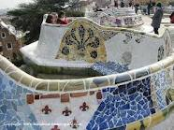
2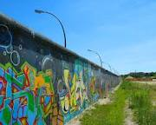
3
4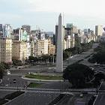
5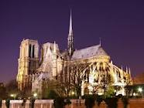
6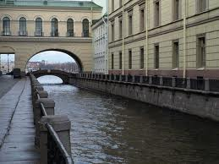
7
8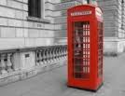
9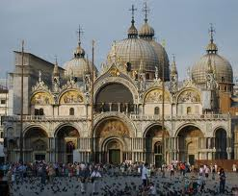
10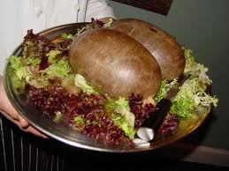
ACTIVITY 2
Here are some images connected to the places where we have decided to go on holiday. What are they? Where are we going to find them? Look at the examples and try to complete numbers 1 to 10 with the cities and countries in the following box:
Paris (France) Berlin (Germany) Buenos Aires (Argentina) Barcelona (Spain) Rio de Janeiro (Brazil) Edinburgh (Scotland) St Petersburg (Russia) Venice (Italy) Mexico City (Mexico) London (England)

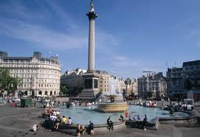
Examples:
We are going to visit Trafalgar Square in London, England.

We are going to eat tortilla in Barcelona, Spain.
- We are going to visit_________________________________________________
- We______________________________________________________________
- _________________________________________________________________
- _________________________________________________________________
- _________________________________________________________________
- _________________________________________________________________
- _________________________________________________________________
- _________________________________________________________________
- _________________________________________________________________
- _________________________________________________________________

ACTIVITY 3

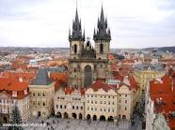
- We are going to travel by _______________
- ____________________________________________________________________
- ____________________________________________________________________
- ____________________________________________________________________
- ____________________________________________________________________
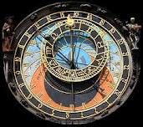

- We are going to travel by_______________
- ____________________________________________________________________
- ____________________________________________________________________
- ____________________________________________________________________
- ____________________________________________________________________
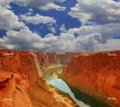

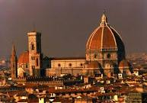
- We are going to travel by_____________
- ________________________________________________________________
- ________________________________________________________________
- ________________________________________________________________
- ________________________________________________________________

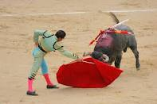
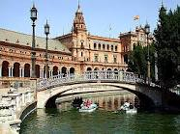
- We are going to travel by_________________
- ________________________________________________________________________
- ________________________________________________________________________
- ________________________________________________________________________
- ________________________________________________________________________

- We are going to travel by_________________
- ________________________________________________________________________
- ________________________________________________________________________
- ________________________________________________________________________
- ________________________________________________________________________
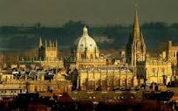
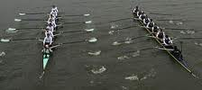

- We are going to travel by________________
- ______________________________________________________________________
- ______________________________________________________________________
- ______________________________________________________________________
- ______________________________________________________________________

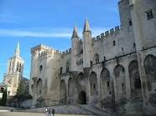
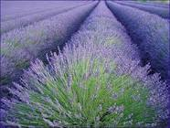

- We are going to travel by_____________
- ________________________________________________________________
- ________________________________________________________________
- ________________________________________________________________
- ________________________________________________________________
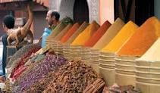
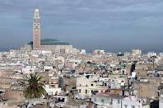

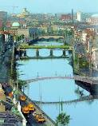

- We are going to travel by_________________
- ________________________________________________________________________
- ________________________________________________________________________
- ________________________________________________________________________
- ________________________________________________________________________
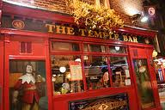

- We are going to travel by_______________
- ____________________________________________________________________
- ____________________________________________________________________
- ____________________________________________________________________
- ____________________________________________________________________
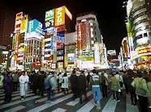

- We are going to travel by_______________
- ____________________________________________________________________
- ____________________________________________________________________
- ____________________________________________________________________
- ____________________________________________________________________
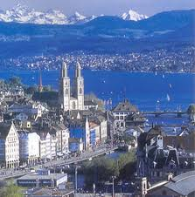
Instructions Activity 3:
Advice: Cut off the cards above and , if possible, laminate them so you can use them many times.
Give your students one of the cards. They have to search for information about the cities on the cards (either at school if they have the possibility to use PCs, or as homework). Then, they have to complete the 5 sentences on the card using “going to” for future plans (if you want to keep the cards for other occasions, ask your students to write the sentences in their notebooks). Remind them to write the most generic information in the 1st sentences and then go to the most specific one.
You can use this activity in the same way as “Going To…places in town” (1/4). Here are the rules modified to be used with cities and countries:
Rules:
- One student comes to the front of the class and introduces the activity using the sentence “I’m going to speak about my and my friends’ plans for next holidays”. Then, slowly, he/she starts reading the clues about the place the other students have to guess. You can give points like this:
  - Guess after the 1st clue: 5 points (nearly impossible as they should only say the means of transport they’re going to use!)
  - Guess after the 2nd clue: 4 points
  - Guess after the 3rd clue: 3 points, etc.
- Encourage your students to be patient and listen to at least 2 or 3 clues (unless they are completely sure of their guess), to stop them from telling places at random.
- If a student says the wrong place, he/she cannot try again until the next card is read.
VARIATION:
Instead of reading the clues on the cards, your students can practise asking questions to guess the mysterious place. Some examples can be the ones below:
- Who is this plan for? (This is the only Wh-question students can ask, as the answers to the questions must only be Yes or No)
- Are you going to spend a lot of money for the journey?
- Are you going to eat cheese/chocolate/etc. there?
- Are you going to stay by the sea?
- Are you going to speak English??
- Are you going to see any shows?
- Are you going to drink beer/vodka/etc.?
- Are you and your friends going to visit any museums
- Are you going to see the Tour Eiffel?
- etc.
Don’t allow questions such as “Are you going to Munich/Rome/Stockholm?”
Encourage your students to think about other questions.
If they are not able to guess the place after having asked a high number of Yes/No-questions, allow them to try asking some Wh-ones.
The student who guesses the mysterious city/country, wins the card. The student with the most cards at the end is the winner.

Solutions: Activity 2
Remind that this activity is connected to the one in the doc “Going to…countries in the world! (3/4)”.
Pictures:
- Park Güell (by Gaudi): Barcelona, Spain.
- Berlin’s Wall: Berlin, Germany.
- Coconut Water: Rio de Janeiro, Brazil.
- Obelisk in Plaza de la República: Buenos Aires, Argentina.
- Notre Dame Cathedral: Paris, France.
- Canal: St Petersburg, Russia
- Tacos: Mexico City, Mexico.
- Red Telephone Box: London, England.
- San Marco’s Square: Venice, Italy.
- Haggis: Edinburgh, Scotland.

You can encourage your students to think about any other thing, food or monument they can find, visit, eat, etc in one of the countries in the exercise.

Enjoy yourselves!!

