## **2018-2019 EDUCATION YEAR**

## **SEHIT MEHMET YILMAZ IMAM HATIP SECONDARY SCHOOL**

**5TH GRADE QUIZ**

**Name : Class:5/__**

**Surname: Number:**

**Write the words under the pictures. (Kutudaki kelimeleri resimlerin altına yazın) 20**

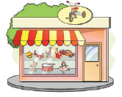**toy shop – supermarket – restaurant - school – hospital – cinema – stationery - playground – bank – police station**



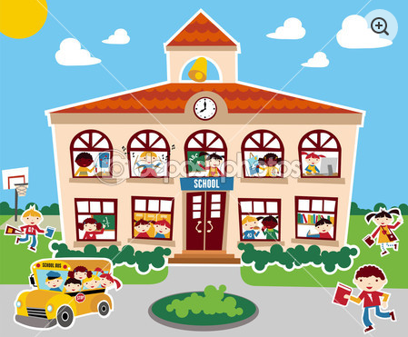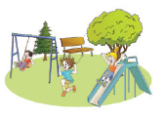



**Choose the correct answers to the questions given below. 20**

**( )1**.How are you today? A)I’m eleven years old.

**( )2**.How many languages do you speak? B) I am from England.

**( )3**.Where are you from? C)Fine.Thanks.And you?

**( )4**.How old are you? D)My favourite class is English.

**( )5**.What is your favourite class? E)Two.Turkish and English.

**FILL IN THE BLANKS WITH “ in , under, on , in front of, behind” 20**

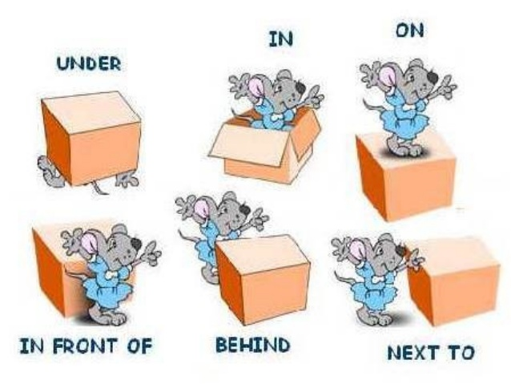

**Write the names of the classes.(derslerin isimlerini yazınız) 20**

***Physical education - Art - Science - Social studies - English***

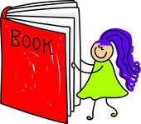 

**………………………… ……………………… …………………………. ……………………… ……………………………**

**Fill in the blanks.(boşlukları doldurunuz)  *20***

**COUNTRIES NATIONALITIES**

England …………………………….………..

France ……………………..……………….

…………..…………………….... Spanish

…………………………………. Russian

Turkey …………………………….………

MEHMET DEGERLI

