**Conversation 1**

Good morning. How are you?

Good morning teacher.

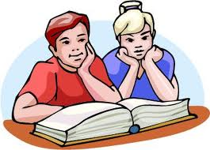 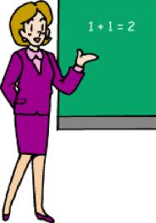

Fine, thank you. And you?

Fine.

 

My name is Rick.

What is your name?

 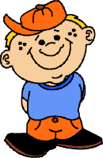

Fine, thank you.

How are you Rick?

 

|  |  |
| --- | --- |
|  | Fine |
|  |  |
| How are you? | OK |
|  | Great! |
|  | So-so |