Name_______________________________ Date________________

GREETINGS

Match the pictures with the speech bubble

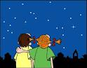

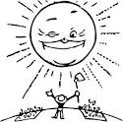

This worksheet was provided by Tc. Lilian Porras – EFL Teacher

