GREETINGS (LOS SALUDOS)  - Listen and repeat  - Complete  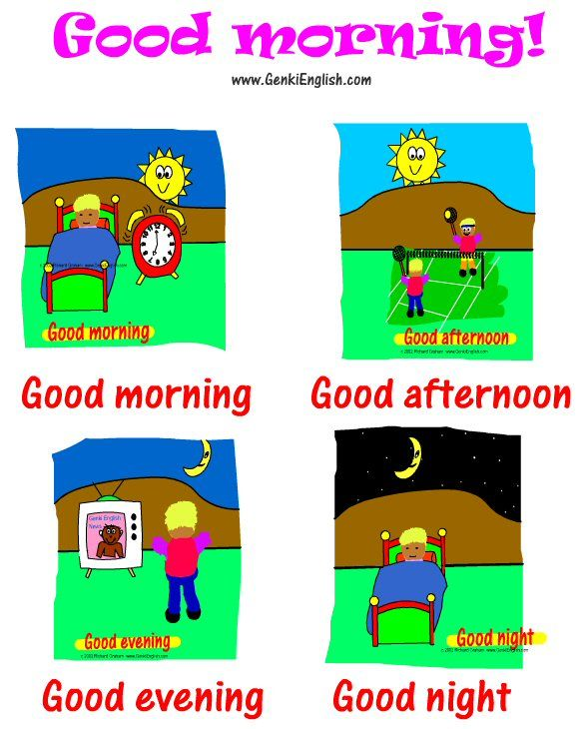  LOOK AT THE TIME.  HOW DO YOU GREET?  02.15 PM _________________  6.30 PM __________________  8.00 AM __________________  12.00 AM _________________  10.00 PM _________________  7.00 PM __________________ | GREETINGS (LOS SALUDOS)  - Listen and repeat  - Complete  LOOK AT THE TIME.  HOW DO YOU GREET?  02.15 PM _________________  6.30 PM __________________  8.00 AM __________________  12.00 AM _________________  10.00 PM _________________  7.00 PM __________________

