Greetings

1. *Write.*

Hello Goodbye

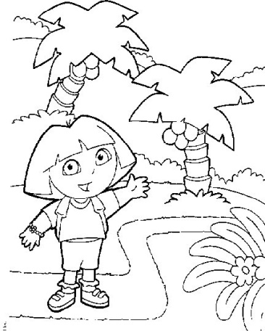

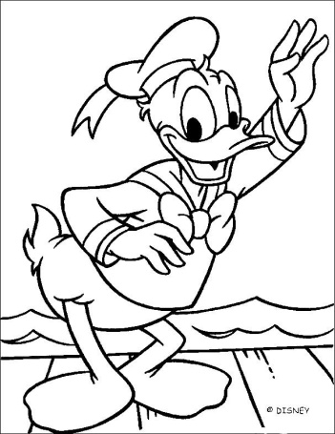

____________________ ____________________

1. What is your name?

________________________________________________

1. How are you?

☺_______________________________________

😐_______________________________________

☹_______________________________________

1. How old are you?

____________________________________________________________