**ELISA CHIARI ELEMENTARY SCHOOL**

**ENGLISH QUIZ**

**GREETINGS AND FAREWELLS**

**STUDENT: ______________________________ LEVEL: _______________ DATE: _____________________**

**SCORE: _____________/14 GRADE: ___________________**

1. **WRITE THE CORRECT EXPRESSION UNDER EACH PICTURE. 10 PTS**

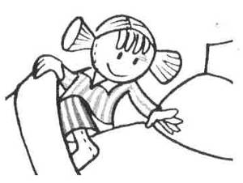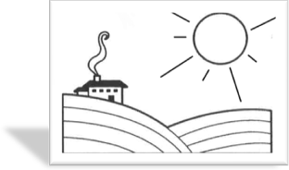****

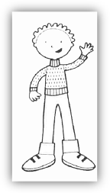

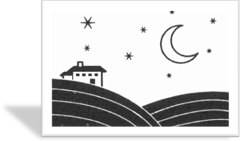

**WORD BANK**

* **SEE YOU TOMORROW**
* **GOOD AFTERNOON**
* **GOOD MORNING**
* **GOOD EVENING**
* **GOOD NIGHT**



1. **ANSWER THE QUESTIONS. 4 pts**
2. What is your name?

___________________________________________________

1. How old are you?

____________________________________________________

**ELISA CHIARI ELEMENTARY SCHOOL**

**ENGLISH QUIZ**

**GREETINGS AND FAREWELLS**

**STUDENT: ______________________________ LEVEL: _______________ DATE: _____________________**

**SCORE: _____________/10 GRADE: ___________________**

1. **GLUE THE PICTURES IN THE CORRECT PLACE. 10 PTS**

GIRL

BOY

APPLE

**3**

**1**

**5**

**4**

**2**

GOOD BYE

GOOD MORNING



[](http://www.google.es/url?sa=i&rct=j&q=boy+picture&source=images&cd=&cad=rja&docid=2rnj43Lsf9o1bM&tbnid=DctRHEhIFcIAXM:&ved=0CAUQjRw&url=http%3A%2F%2Fsp.depositphotos.com%2F6453810%2Fstock-illustration-Cartoon-boy-walking-to-school.html&ei=zJs5UbzXI4r89QT6oICoBA&bvm=bv.43287494,d.eWU&psig=AFQjCNEk-2tu3N2nWV__pPj8zzRmz4EvQw&ust=1362816319658050)

[](http://www.google.es/url?sa=i&rct=j&q=apple+draw&source=images&cd=&cad=rja&docid=4d2uLBO4t1LqGM&tbnid=sMKs-NR6-YEwwM:&ved=0CAUQjRw&url=http%3A%2F%2Fcurvy.suggestsoft.com%2F&ei=Ipw5UY-jGIOq8AT06YGAAg&bvm=bv.43287494,d.eWU&psig=AFQjCNE1Sk87cw0N44qTUS6QNX5xCrD-hw&ust=1362816401417622)



[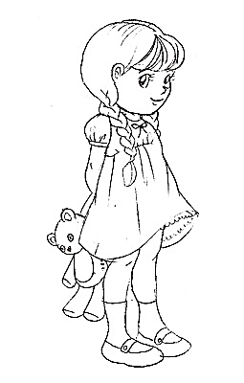](http://www.google.es/url?sa=i&rct=j&q=girl+drawing&source=images&cd=&cad=rja&docid=aEpHfK6YLwOvrM&tbnid=aUz3rNUHc8A5JM:&ved=0CAUQjRw&url=http%3A%2F%2Fjustfree.org%2Fgirl-drawing&ei=1Jw5UcfTGIPW9ASc6IHQAQ&bvm=bv.43287494,d.eWU&psig=AFQjCNFXJc38gznabpq3cOI9XffDdaIGvA&ust=1362816535256504)

GOOD BYE