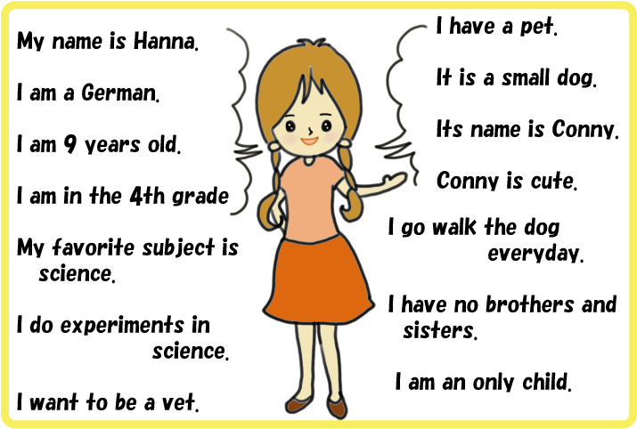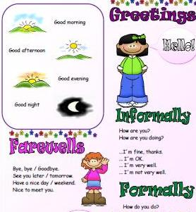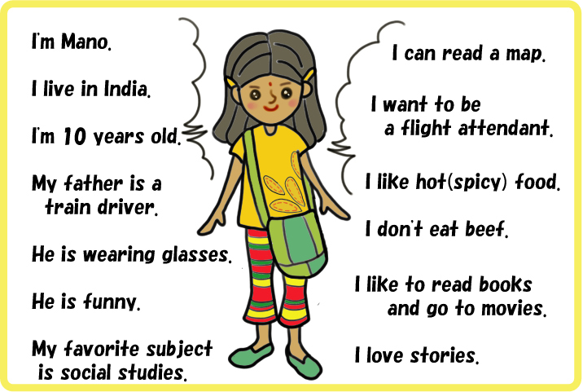Greetings & Self Introduction

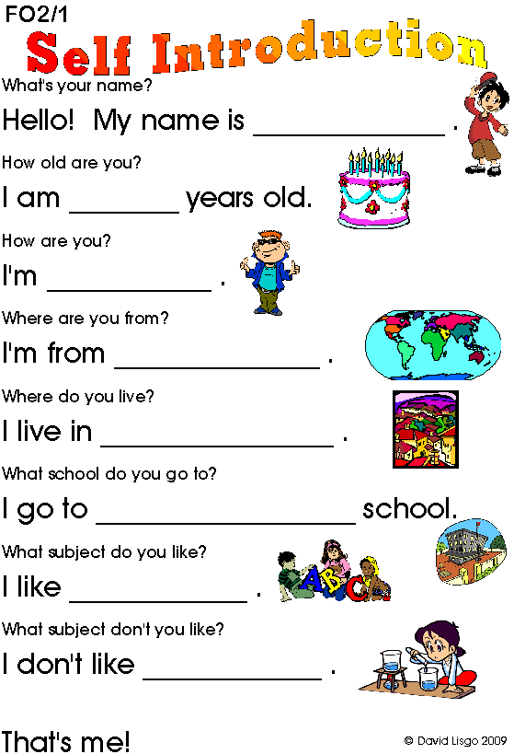

**Let sing together :**

**Hello.. Hello.. Hello..**

**Hello and how are you..**

**I’m glad to meet with you..**

**And you.. and you.. and you..**