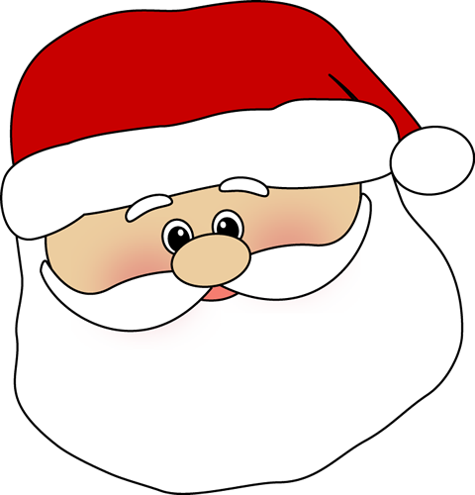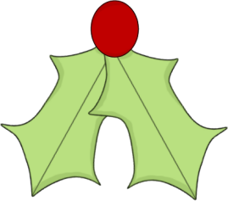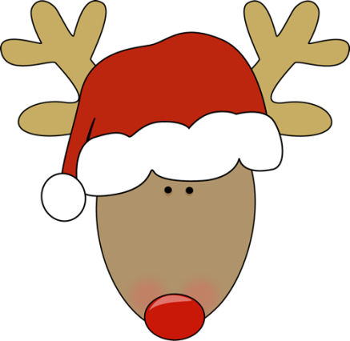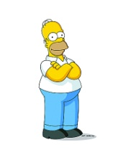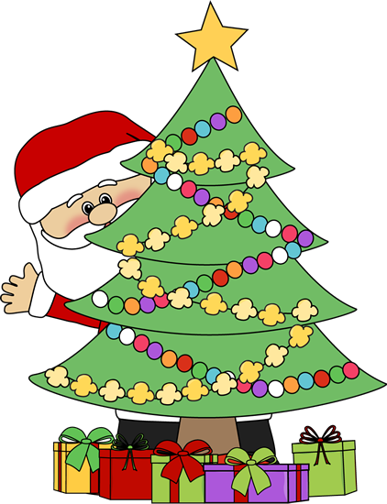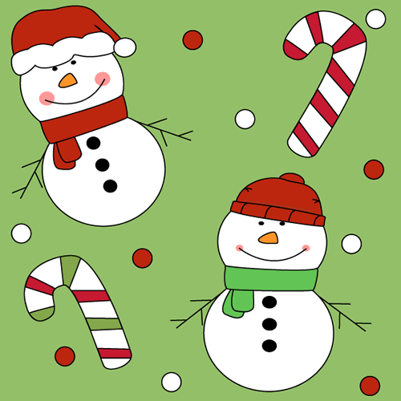.

Ho Ho Ho Quiz for Kids

All answers have the two letters HO in them!

1. It is a place people live. You may live in one, too. ____________

2. What most students have in summer. _______________

3. You need a camera to take them. _________________________________

4. A favourite candy among kids –and grown-ups. ______________________

5. A boy’s name. __________________________________

6. A person who entertains guests. ___________________

7. A Christmas decoration. __________________________

8. A curved or bent thing for holding things. ____________

9. If the lake is frozen and you want to fish in it, you must drill a……. _________________

10. A film genre. ________________________

11. Beer, wine and whisky are drinks with …… ___________________________________

12. A brass instrument. ___________________

13. An iron instrument attached to s ship. ___________________

14. Opposite of long. ____________________________________

15. iPad, iPod and i….. ___________________________________

16. A domestic animal you can ride. _______________________

17. “Idol”, “Who Wants to be a Billionaire”, “X-Factor” are all …..

__________________

18. What you can do with a gun. ________________

19. What you wear on your feet. ________________

20. Name of this person. ______________

Merry Christmas Everybody!