Macintosh HD:Users:isabel:Desktop:Unknown-8.jpeg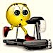**Macintosh HD:Users:isabel:Desktop:images-3.jpeg**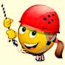Macintosh HD:Users:isabel:Desktop:images.jpeg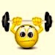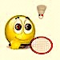Macintosh HD:Users:isabel:Desktop:images-1.jpegMacintosh HD:Users:isabel:Desktop:Unknown-10.jpegMacintosh HD:Users:isabel:Desktop:images-13.jpeg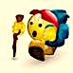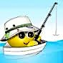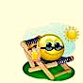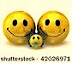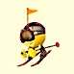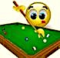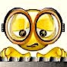**Macintosh HD:Users:isabel:Desktop:Unknown-2.jpeg**Macintosh HD:Users:isabel:Desktop:images-24.jpeg

1. **p**ainting
2. watching tv
3. playing the guitar
4. yoga
5. dice
6. chess
7. knitting
8. listen to music
9. speaking on the phone
10. writing
11. doing gymnastics
12. sleeping
13. going to the cinema
14. reading
15. playing computer games
16. playing cards
17. billiards
18. cooking
19. pottery
20. football
21. climbing
22. rugby
23. hockey
24. icehockey
25. canoeing
26. baseball
27. karate
28. boxing
29. tennis
30. biking
31. diving
32. archery
33. badminton

15. basketball

16. weightlifting

17. swimming

18. skiing

19. surfing

**WHAT ABOUT SOME SPORTS?.**

(Match the activities with the pictures)

1. drinking beer

2. eating icecreams

3. playing with the sand

4. shopping

5. skating

6. hiking

7. barbecues

8. gardening

9. skateboarding

10. sunbathing

11. walking

12. eating out

13. going for a picnic

14. being with friends

15. being with the family

16. going to parties

17. photography

18. playing with the sleigh

19. fishing

20. driving

**WHAT DO YOU LIKE DOING IN YOUR FREE TIME?**

**WHAT ABOUT SOME INDOOR**

**ACTIVITIES?**