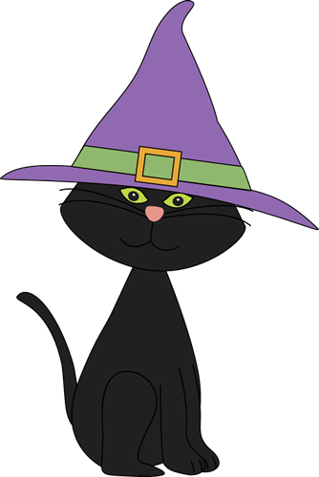
allowed / aloud
buy / by / bye
cell / sell
cent / scent / sent
flu / flew
knot / not
plane / plain
read / red
wail / whale
which / witch
who’s / whose
Fill in the right option in the sentences below.

1. I don’t know __________ fault it is.
2. What type of animal is a humpback? A ____________.
3. Michael is going to _________ his car to get some money.
4. The bird _________ over my head.
5. They are not _________ in here. They are too young.
6. His clothes are very _________, don’t you think?
7. I want you to untie the __________.
8. I think she looks very much like a ________. Look at her warts.
9. _________ coming tonight? I am not sure how many plates I need.
10. You better go to bed. I think you have got the ___________. You have a fever.
11. Who wants to read ________ from the new book?
12. The Danish flag has two colours ________ are white and _________.
13. The ________of roses makes me feel good.
14. Do you know which ________ we are going with to the USA?
15. I need one _______ to pay the bill. Please, help me.
16. He said _______ and left.
17. I do _________ know him. He is a stranger to me.
18. Mum is going to ________ me a new costume for Halloween.
19. Can you hear the __________ of the siren?
20. Have you ________ the book “The Boy in the Striped Pyjamas” ________ John Bourne?
21. The prisoner was locked up in a __________ for two weeks.
22. My uncle _________ the letter ten days ago. It is still not to be found in my mailbox.

Key:
1. whose 2. whale 3. sell 4. flew 5. allowed 6. plain 7. knot 8. witch 9. Who’s 10. flu 11. aloud 12. which, red 13. scent 14. plane 15. cent 16. bye 17. not 18. buy 19. wail 20. read, by 21. cell 22. sent

