

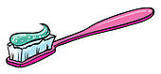

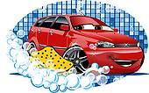

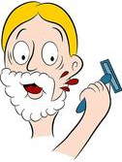

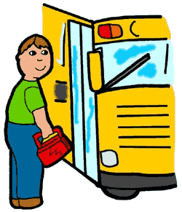

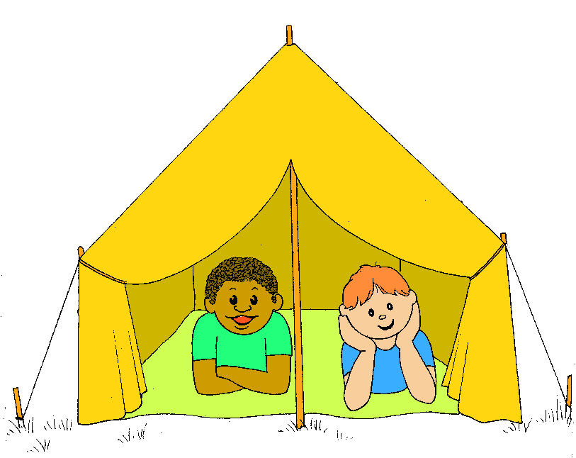

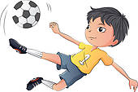

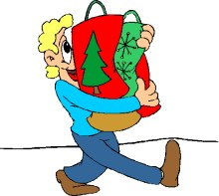

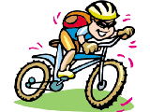

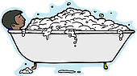

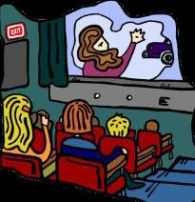



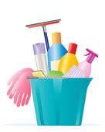

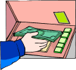



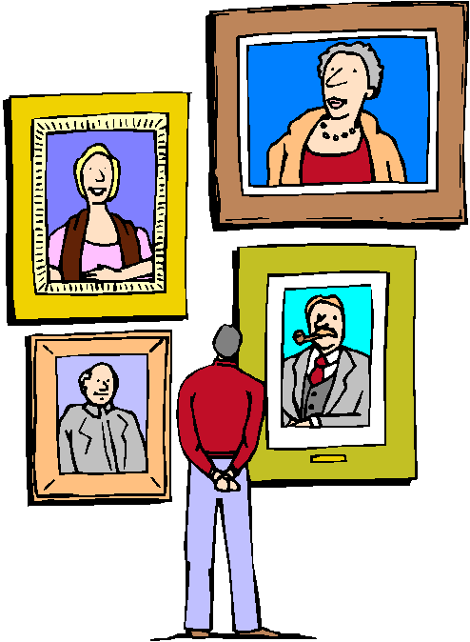

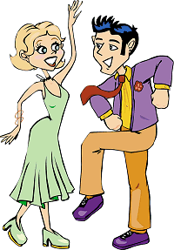



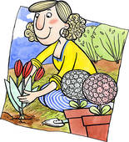

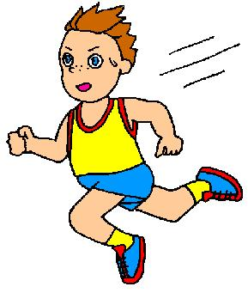

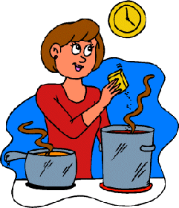

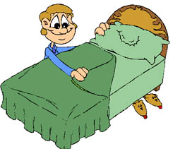

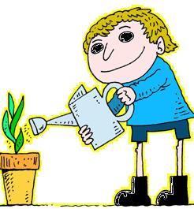



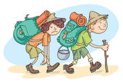

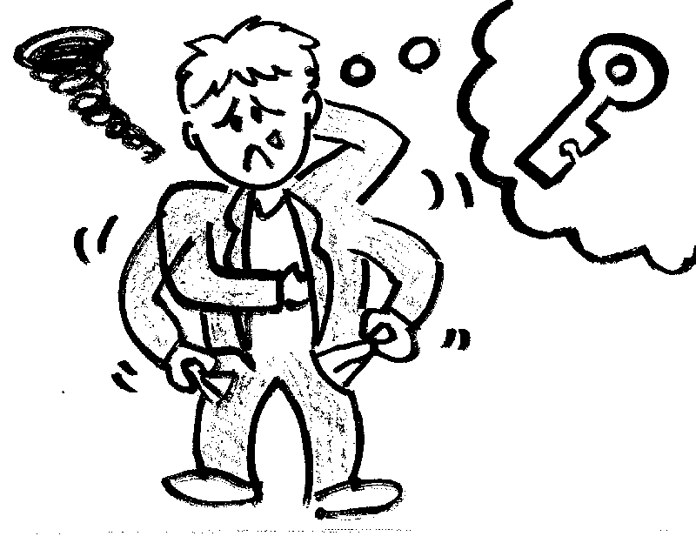

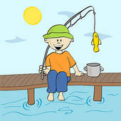

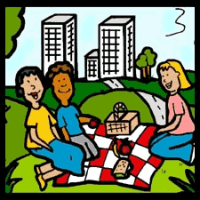

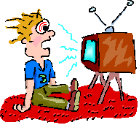



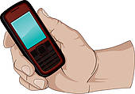

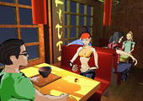

C:\Users\Silvia\Documents\minhas imagens\ILUSTRAÇÕES\CLIPART\ICONES\dinheiro\visa.gif

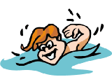





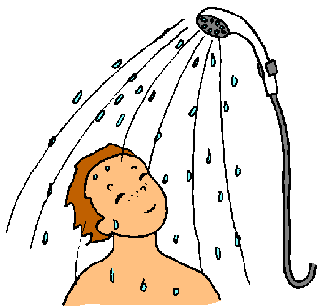

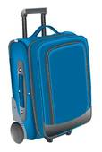



**miss a turn**



always

usually

normally

gererally

frequently

often

sometimes

occacionally

rarly

seldom

never

once / twice three times ..a day / a week/ month

every week/

month/ year

**ANSWERS**

How often do you take a plane?

How often do you brush your teeth?

How often do you wash the car?

How often do you shave?

How often do you take a bus?

How often do you go camping?

How often do you play football / soccer?

How often do you go to the supermarket?

How often do you ride a bike?

How often do you take a bubble bath?

How often do you go to the cinema?

How often do you have a haircut?

How often do you clean your house?

How often do you go to the bank?

How often do you drink wine?

How often do you visit a museum?

How often do you dance?

How often do you eat a hamburger?

How often do you work in the garden?

How often do you run?

How often do you cook?

How often do you make your bed?

How often do you water the plants?

How often do you read a book?

How often do you go hiking?

How often do you loose your keys?

How often do you go fishing?

How often do you have a picnic?

How often do you watch TV?

How often do you send an e-mail?

How often do you speak on your cell phone?

How often do you go to a restaurant?

How often do you pay with a credit card?

How often do you swim?

How often do you play computer games?

How often do you have a cup of coffee?

How often do you take a shower?

How often do you travel?

How often do you take photos?

**miss a turn**

How often do you clean the windows?

wash

always

usually

normally

gererally

frequently

often

sometimes

occacionally

rarly

seldom

never

once / twice three times ..a day / a week/ month

every week/

month/ year

**Instructions for the teacher.**

**Preparation**

* Print the board games on tick paper or a cardboard; laminate them if you want to use them many times.
* Find tokens for each student.
* Provide dice.
* Divide the class into groups of 3 – 4 students each.
* Give each group a board game and a die.
* Give each student a token (or bean, coin, button, etc.).

**The game**

* The players put their tokens aniwere.They have to comlete a whole tour.
* The first student throws the die and moves his token ahead the corresponding number of squares.
* The student asks a question according the picture, then he answers it using a frequency adverb.
* **Example: How often do you take a plane? I take a plane once a year.**
* If the answer is correct, the student stays, if the answer is incorrect, he has to go back where he came from.
* The first student who takes a number that places his token on “home” or surpasses it is the winner.