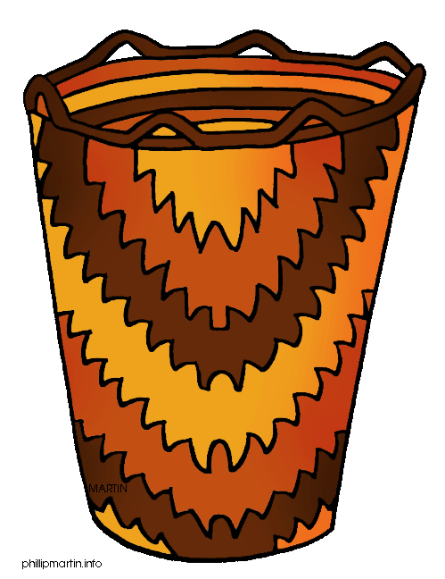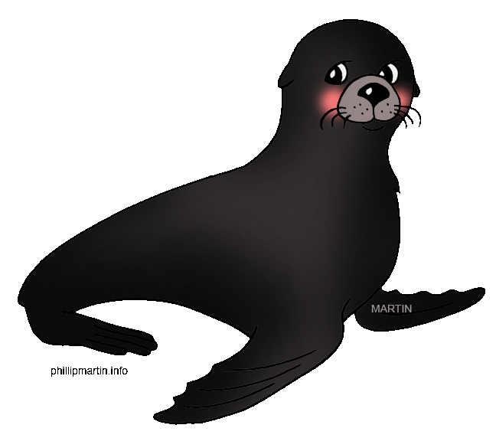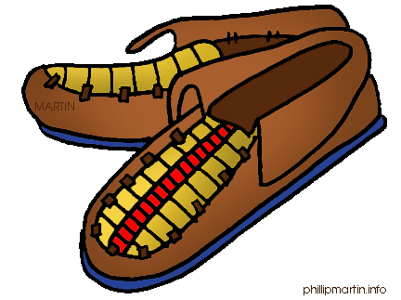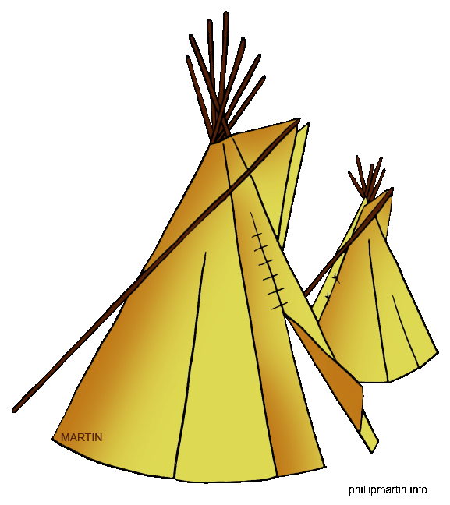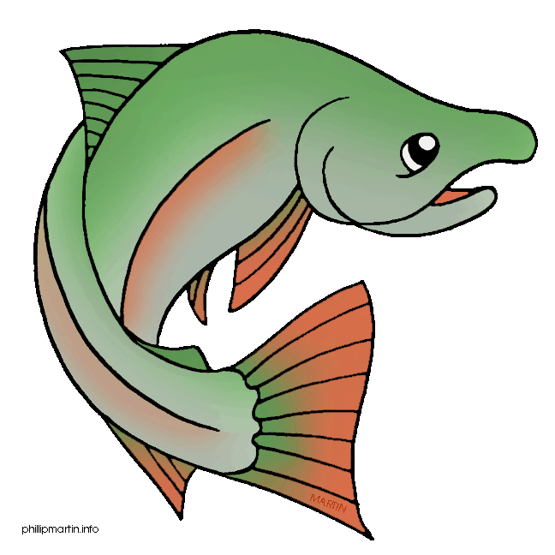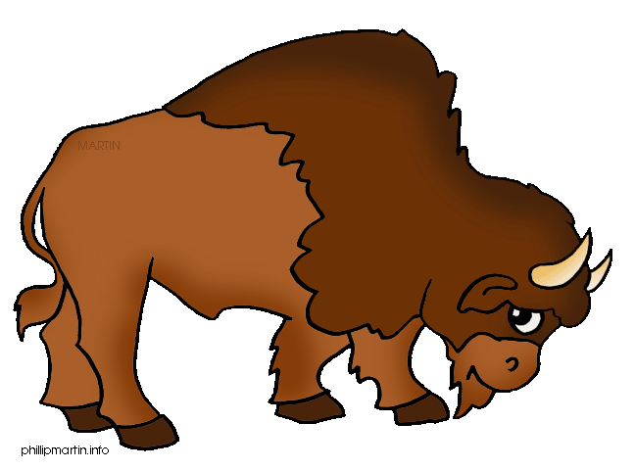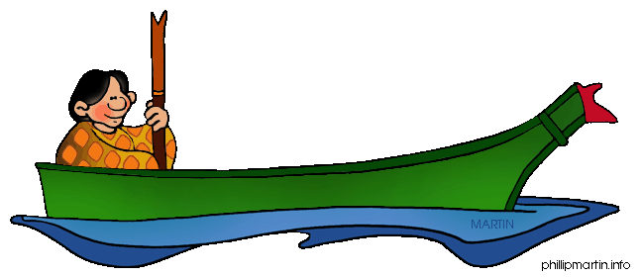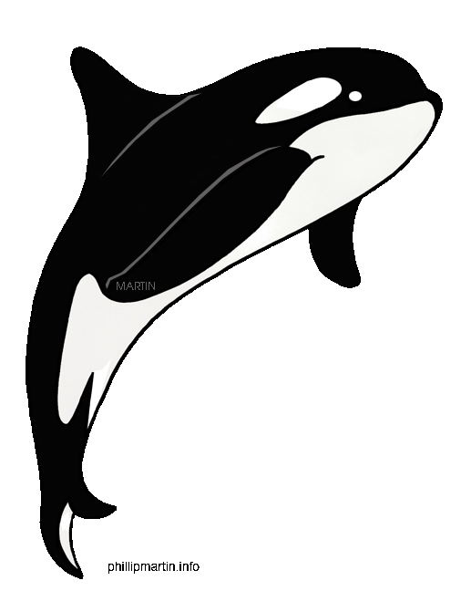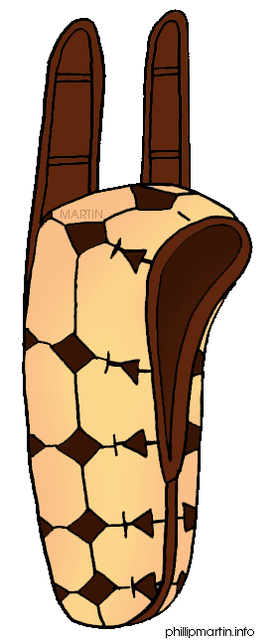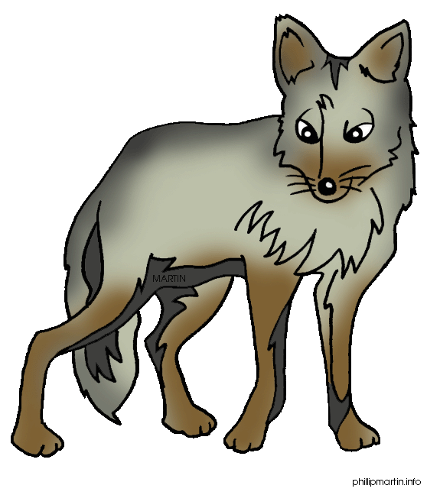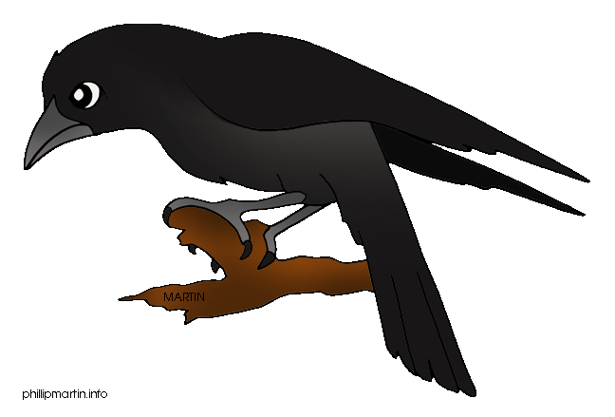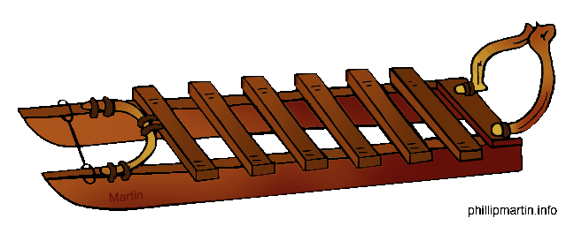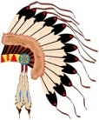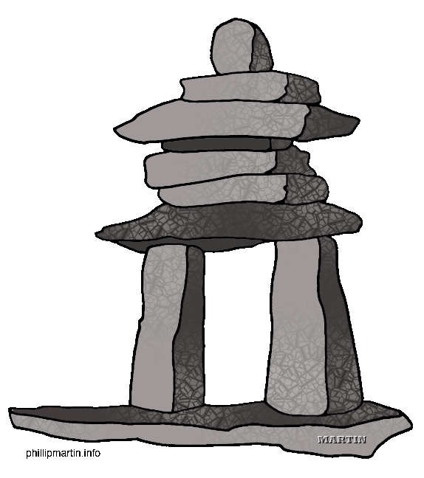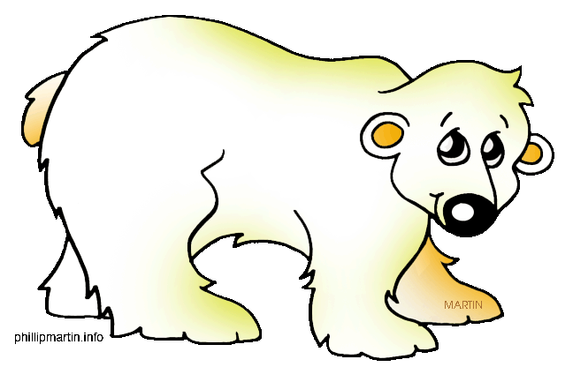

16. Where the first Americans lived in the USA.

18. People who hunt wild animals.

20. Sioux, Blackfoot, Cree, Pueblo are _ _ _ _ _ _.

22. A weapon.

24. Indians slept, cooked and _ _ _ in the tepees.

17. Indians believed in them.

19. The bird which feathers are used for headdresses.

21. A person believed to have magic powers.

23. The leader of a tribe.



T

16. Where the first Americans lived in the USA.

18. People who hunt wild animals.

20. Sioux, Blackfoot, Cree, Pueblo are _ _ _ _ _ _.

22. A weapon.

24. Indians slept, cooked and _ _ _ in the tepees.

17. Indians believed in them.

19. The bird which feathers are used for headdresses.

21. A person believed to have magic powers.

23. The leader of a tribe.

E

F

I

C

N

G

K

U

S

K

U

N

I

S

T

I

R

I

P

S

N

A

M

E

N

I

C

I

M

E

S

H

U

N

T

E

A

R

E

V

S

E

B

I

R

E

A

G

E

L

P

A

I

N

S

T

A

E

R

G

R

A

E

B

R

A

L

O

C

R

A

D

E

E

E

P

T

E

O

N

A

N

O

M

L

A

S

N

I

S

A

C

C

O

M

D

E

L

S

S

E

R

D

D

E

H

A

C

R

L

A

E

T

E

K

S

A

O

L

A

F

F

U

B