[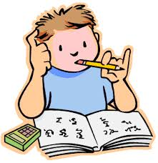](http://www.google.com.tr/imgres?imgurl=http://www.twinhills.k12.ok.us/Images/ClipArt/Before%20School%20Study2.gif&imgrefurl=http://www.twinhills.k12.ok.us/Before%20School%20Study.html&usg=__BWGsMzEMYpWyKDJ4gpDE-h92u9s=&h=385&w=374&sz=16&hl=tr&start=9&zoom=1&itbs=1&tbnid=hSAcmLHpjUWkFM:&tbnh=123&tbnw=119&prev=/images?q=study&hl=tr&gbv=2&tbs=isch:1) **……………………….. EDUCATION TERM**

**MAKBULE SÜLEYMAN ALKAN SECONDARY SCHOOL**

**1st TERM 1st ELECTİVE ENGLISH EXAM**

**5th GRADES**



**Name & Surname: Point:**

**Class & Number :**

**A) Match the greetings with clocks. ( 8 points )**

**(Selamlaşma ifadelerini saatlerle eşleştiriniz.)**

**1.**Good evening **a)** 08:30

**2.**Good morning **b)** 23:00

**3.**Good night **c)** 13:00

**4.**Good afternoon **d)** 19:30

**B) Match the pictures with the words .( 36 points )**

**(Resimleri isimleriyle eşleştirip, sözcüklerin altına resimlerin numaralarını yazınız.)**

[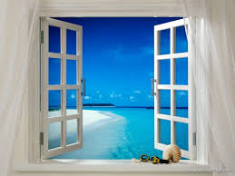](http://www.google.com.tr/imgres?imgurl=http://www.masaustu-resimleri.com/d/885-2/a____k+pencere.jpg&imgrefurl=http://www.masaustu-resimleri.com/v/Cennet/a____k+pencere.jpg.html&usg=__Nz3jhSDEY13An8EVb0B92Gl681M=&h=600&w=800&sz=299&hl=tr&start=1&zoom=1&itbs=1&tbnid=YlkvftNgMhWtUM:&tbnh=107&tbnw=143&prev=/images?q=window&hl=tr&gbv=2&tbs=isch:1)[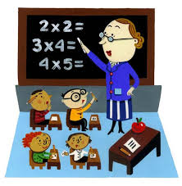](http://www.google.com.tr/imgres?imgurl=http://melanietheteacher.pbworks.com/f/1207068064/Classroom.jpg&imgrefurl=http://melanietheteacher.pbworks.com/My+Ideal+Classroom&usg=__VQPOQldPnXyHrEgeZuJnCzvH7gI=&h=600&w=588&sz=46&hl=tr&start=1&zoom=1&itbs=1&tbnid=JkHe7sBJiway4M:&tbnh=135&tbnw=132&prev=/images?q=classroom&hl=tr&gbv=2&tbs=isch:1)[](http://www.google.com.tr/imgres?imgurl=http://www.barbellsandbacon.com/wp-content/uploads/2009/11/notebook.jpg&imgrefurl=http://shivaazimi-english.blogfa.com/&usg=__fRPIPoxyLvfQvZ7Ru_HIqevT-70=&h=800&w=629&sz=152&hl=tr&start=87&zoom=1&itbs=1&tbnid=8te5ygXj5pGpbM:&tbnh=143&tbnw=112&prev=/images?q=notebook&start=80&hl=tr&sa=N&gbv=2&ndsp=20&tbs=isch:1)[](http://www.google.com.tr/imgres?imgurl=http://www.mclibrary.duke.edu/about/news/books1.gif&imgrefurl=http://www.zemanta.com/learn/&usg=__4H8sq7DTse18mLj5UHJpyqe2Qes=&h=300&w=300&sz=28&hl=tr&start=1&zoom=1&itbs=1&tbnid=Xf58qCfQNAwziM:&tbnh=116&tbnw=116&prev=/images?q=book&hl=tr&gbv=2&tbs=isch:1)[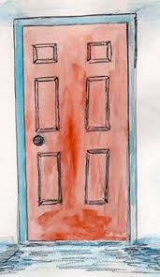](http://www.google.com.tr/imgres?imgurl=http://www.ors.act.gov.au/FairTrading/images/door.jpg&imgrefurl=http://www.ors.act.gov.au/FairTrading/WebPages/Consumers/Consumers_Main.html&usg=__cIi9uHfECZrrfVLwSTCVL6atIAk=&h=525&w=305&sz=35&hl=tr&start=1&zoom=1&itbs=1&tbnid=3Yrevjj3S1ZxlM:&tbnh=132&tbnw=77&prev=/images?q=door&hl=tr&gbv=2&tbs=isch:1)

**……………………… ……………………… …………………… …………………… ……………………**

**[](http://www.google.com.tr/imgres?imgurl=http://patricpeake.files.wordpress.com/2009/12/pencil1.jpg&imgrefurl=http://patricpeake.wordpress.com/ask-mpg/&usg=__o8GAukaMqnHXfpkNsPkv6siiXhA=&h=500&w=500&sz=28&hl=tr&start=3&zoom=1&itbs=1&tbnid=j3Jf-Ioo6_qwWM:&tbnh=130&tbnw=130&prev=/images?q=pencil&hl=tr&gbv=2&tbs=isch:1)**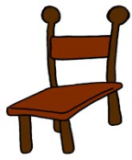

**…………………… ………………… …………………… ………………………**

**door – umbrella - pencil - book – chair – sharpener - notebook - classroom - window**

**C)** **Match classroom instructions with their Turkish meaning.(16 points)**

**(Verilen Türkçe-İngilizce ifadeleri birbiriyle eşleştiriniz.)**

**1.**Open your book ………… **a)** Otur

**2.**Stand up…………… **b)**Yaz

**3.**Be quiet…………… **c)**Defterini aç

**4.**Write …………….. **d)**Sessiz ol

**5.**Open your notebook ………… **e)**Sessizceokuyun

**6.**Sit down ………….. **f)**Kalk

**7.**Read silently………………… **g)**Kitabını aç

**8.**Repeat after me ……….. **h)**Benden sonra tekrar edin

**D) Write the names of these places.(Bina isimlerini resimlerin altına yazınız.)**

**supermarket – library – post office – cafe – hospital – cinema – police station**

**(24 pts.)**

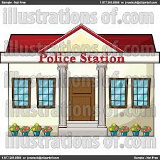

**……………………… ……………………… ……………………… …………………………**





**………………………… ……………………… ………………………… ………………………**

**E) Fill in the blanks with “ am “ , “ is “ , “ are “ .**

**(Boşlukları ‘’am, is, are “ ile doldurun) (16 points)**

I ______ Sally.

You ______ Mike.

He ______ David.

She _____ Annie**.**

It _____ Pimpoli.

We ______ Diana and Gary.

You _____ students.

They ______David and Annie.



[www.eegitimim.com](http://www.eegitimim.com/)