5. SINIF İNGİLİZCE 2. DÖNEM 1. YAZILI SORULARI

1. What’s the matter with you?

A. I have a measles
B. She has a runny nose
C. I like cycling
D. You should drive fast
2.
I have a broken arm .

A. B.

C. 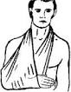 D. 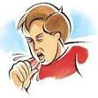

3. A: I have the flu.
B: You should …………………..
A. use tissue B. drink water
C. eat a hamburger D. go out
4. March , April and May are ……….. months.
A. autumn
B. winter
C. spring
D. summer

5. 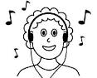
………………………..
A. We mustn’t listen to loud music
B. We mustn’t run in the corridor
C. We mustn’t ride bicycles
D. We mustn’t play in the classroom

6. 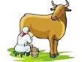
……………………… ………………………. …………………..

………………………….

7.
What is that?
A. present
B. decorate
C. beverage
D. invitation card

8.
You should ………………………………………
A. see a dentist
B. carry heavy things
C. stay in bed
D. drink cold drinks
7.
We mustn’t …………………….
A. feed the animals
B. play in the classroom
C. drive fast
D. run in the corridor
8.
……………………….
A. gift
B. beverage
C. invitation card
D. guest list

9. 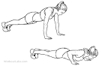 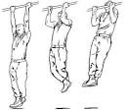
……………………….. ………………… ……………………………

10.
……………….. ……………………..
…………………. ……………………..
…………………. ………………………
(aylar) (aylar)

………………………. ………………………
……………………….. ……………………...
………………………… ………………………
(aylar) (aylar)

GOOD LUCK

