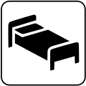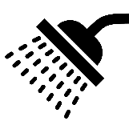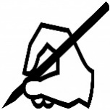

START

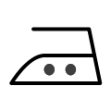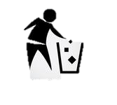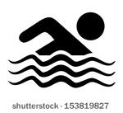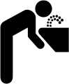

FINISH

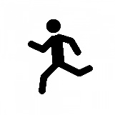



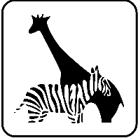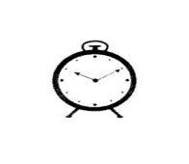

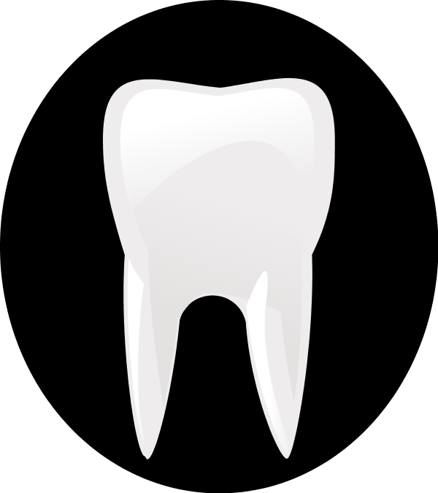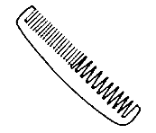

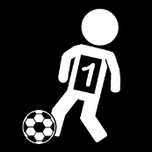

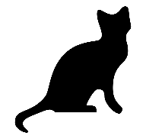

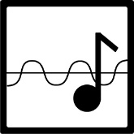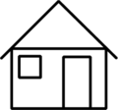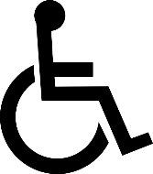

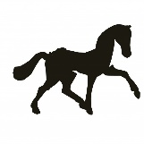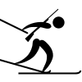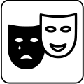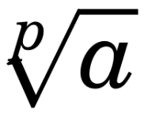

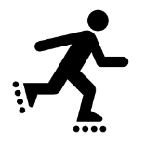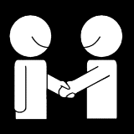



**NOW**

**AT PRESENT**

**AT THE MOMENT**

**CURRENTLY**

**LAST**

**AGO**

**WHEN?**

**YESTERDAY**

**JUST**

**EVER**

**NEVER**

**HOW MANY TIMES?**

**HOW OFTEN?**

**FROM TIME TO TIME**

**AT THE WEEKEND**

**HARDLY EVER**

**USUALLY**

**RARELY**

**OFTEN**

**HARDLY EVER**

**ALREADY**

**YET**

**FOR/SINCE**

**HOW LONG?**

**WHILE**

**WHEN**

**AT THE TIME OF**

**NEXT**

**TOMORROW**

**IN**

**WHEN?**

**WHILE**

**WHEN**

**AT THE TIME OF**

**USUALLY**

**WHEN**

**WHEN**

**AT THE TIME OF**

**RARELY**

**AT THE TIME OF**

**WHEN**

**AT THE TIME OF**

**OFTEN**

**LAST**

**AGO**

**WHEN?**

**YESTERDAY**

**HARDLY EVER**

**AGO**

**AGO**

**WHEN?**

**YESTERDAY**

**HOW OFTEN? **

**WHEN?**

**AGO**

**WHEN?**

**YESTERDAY**

**OCCASSIONALY**

**AT THE WEEKEND**

**YESTERDAY**

**AGO**

**WHEN?**

**YESTERDAY**

**ALREADY**

**YET**

**FOR/SINCE**

**HOW LONG?**

**NEXT**

**TOMORROW**

**IN**

**WHEN?**

**FOR/SINCE**

**YET**

**FOR/SINCE**

**HOW LONG?**

**TOMORROW**

**TOMORROW**

**IN**

**WHEN?**

**HOW LONG?**

**YET**

**FOR/SINCE**

**HOW LONG?**

**WHEN?**

**TOMORROW**

**IN**

**WHEN?**

**IN**

**TOMORROW**

**IN**

**WHEN?**

**JUST**

**YET**

**FOR/SINCE**

**HOW LONG?**

**NOW**

**AT PRESENT**

**AT THE MOMENT**

**CURRENTLY**

**EVER**

**YET**

**FOR/SINCE**

**HOW LONG?**

**NEVER**

**YET**

**FOR/SINCE**

**HOW LONG?**

**AT PRESENT**

**AT PRESENT**

**AT THE MOMENT**

**CURRENTLY**

**AT THE MOMENT**

**AT PRESENT**

**AT THE MOMENT**

**CURRENTLY**

**HOW MANY TIMES?**

**YET**

**FOR/SINCE**

**HOW LONG?**

USEFUL PHRASES

|  |  |
| --- | --- |
| 1. Read a book |  |
| 1. Write a letter |  |
| 1. Take a shower |  |
| 1. Sleep in bed |  |
| 1. Do jogging |  |
| 1. Eat out/eat at the restaurant |  |
| 1. Drink water |  |
| 1. Swim in the pool |  |
| 1. Clean/empty the rubbish |  |
| 1. Do ironing |  |
| 1. Surf the Net/use a computer |  |
| 1. Repair something/build something |  |
| 1. Drive a car |  |
| 1. Go shopping |  |
| 1. Go to the ZOO |  |
| 1. Go to the cinema |  |
| 1. Wake up |  |
| 1. Take the dog for a walk/walk the dog |  |
| 1. Make a snowman |  |
| 1. Comb sb’s hair |  |
| 1. Play chess |  |
| 1. Sew something |  |
| 1. Visit a dentist |  |
| 1. Play the guitar |  |
| 1. Play football |  |
| 1. Feed the cat |  |
| 1. Go by plane |  |
| 1. Send a letter |  |
| 1. Talk on the phone |  |
| 1. Drink coffee |  |
| 1. Take photos |  |
| 1. Help the disabled/do voluntary work |  |
| 1. Stay at home |  |
| 1. Listen to music/play music |  |
| 1. Do Maths homework/count |  |
| 1. Go to the theatre |  |
| 1. Paint a picture |  |
| 1. Ride a horse |  |
| 1. Go skiing |  |
| 1. Sing a song |  |
| 1. Meet friends/talk to friends |  |
| 1. Cook a meal |  |
| 1. Go rollerblading |  |