PREPOSITIONS
- 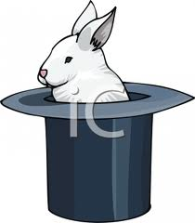 There is a rabbit _________________ the hat.
- 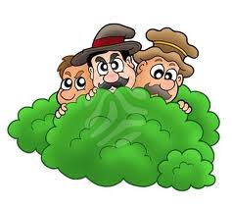 There are three men _________________ the tree.
- 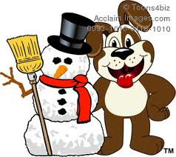 Bingo is ____________________ the snowman.
- 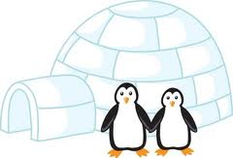 Penguins are _____________________ their house.
- 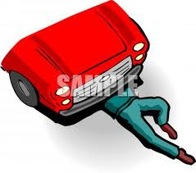 Mr. Mehmet is _____________________ the car.
- 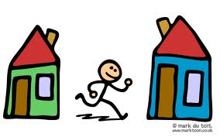 Alican is ______________________ two houses.
- 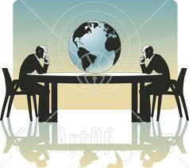 Mr. Güçlü is ______________________ Mr. Suçlu.
- 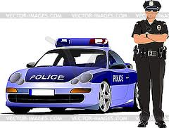 There is a policeman ____________________ the car.
- 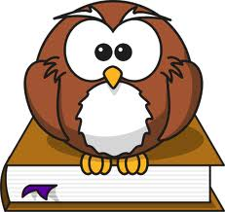 There is an owl ____________________ the book.

Places In My Town
- 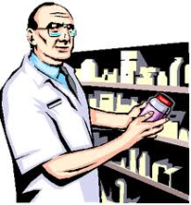 We buy drugs from the _______________________ .
- 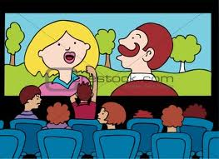 We watch films at the _______________________ .
- 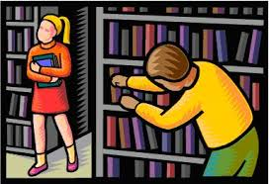 We read book in the ________________________ .
- 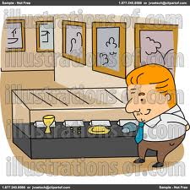 We visit _____________________ to see the ancient belongings.
- 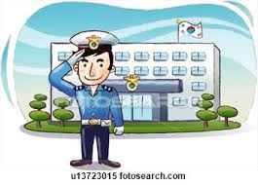 The policeman is in front of the ________________________ .
- 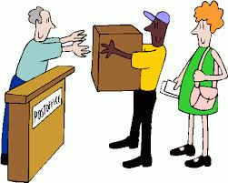 We send letters or post packets in the ________________________ .
- 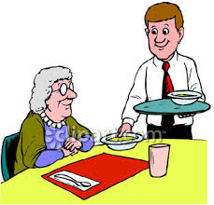 We have something to eat in a ________________________ .
- 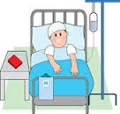 We go to a ______________________ when we are ill.
- 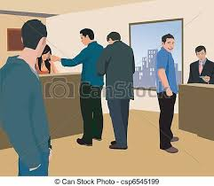 We get money from the ___________________________ .
- 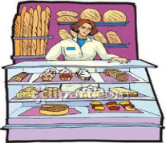 We buy bread from the ____________________________ .

