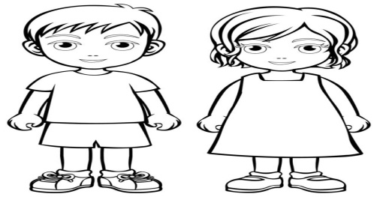**SELF – INTRODUCTION**

Hello. My name is___________________________.

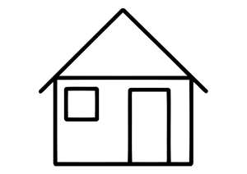I am _______________ years old.

I live in ____________________________________.

I go to__________________________ school.

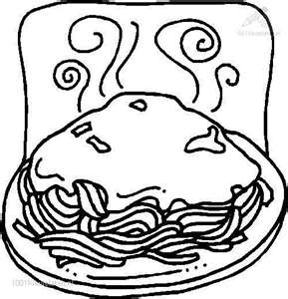My parents are ___________________________.

My favorite food is ______________________.

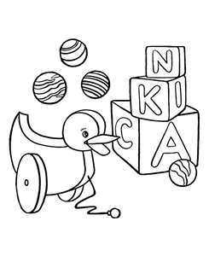

I like ____________________________________.