INVENTORS and EXPLORERS
- Answer the questions.
- Do you know these people?
- Who are they ?
- What do you know about them?
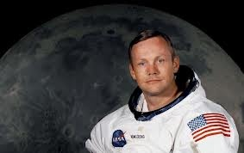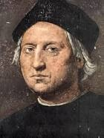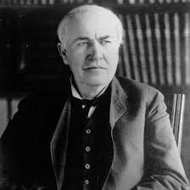
Neil Armstrong was the first explorer on the moon .
He explored the Moon in 1969.
His exploration was very important for him. Because Neil Armstrong was the first man to step on the moon and he said : “ That’s one small step for (a) man ; one giant leap for mankind.”

- What did these people do for us ? Let’s read and learn.
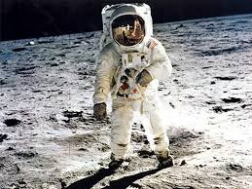

Christopher Colombus was an discoverer.
He discovered America in 1492.
With his discovery the new world was revealed.

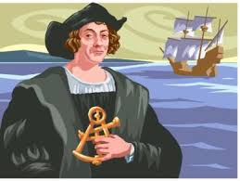
Thomas Edison was one of the world’s greatest inventor.
He had 1.093 inventions.
He invented the light bulb .
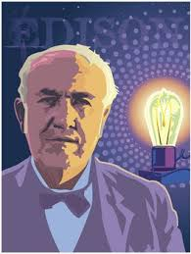

explorer (n)
explore (v)
invent (v)
inventor (n)

exploration (n)
invention (n)

discover (v)

discovery (n)
discoverer (n)

- Look at the sentences and answer the questions.

- Neil Armstrong explored the moon in 1969.

- Christopher Colombus discovered America in 1492.

- Thomas Edison invented the light bulb.

- regular verbs

- irregular verbs

- The highlighted verbs are .
- simple present tense

- simple past tense
- We use in these sentences.

- We add to the end of regular verbs to make Simple Past Tense.
- nothing
- –ed

Hi. I’m Peter . I want to learn something about inventors and explorers. Can you help me please?
- Choose one of the dialogues below. Talk to Peter about these inventors and explorers.

- 4.
Peter : Do you know Sir Admund Hillary?
You : No, I don’t know him. Who is he?
Peter : He was an explorer. He explored the Mt. Everest .
Peter : Do you know Baron von Drais
You : Yes, I know him. He was an inventor.
Peter : What did he invent?
You : He invented the bicycle.

- 5.
Peter : Do you know Evangelista Toricelli?
You : No, I don’t know him. Who is she?
Peter : She was an inventor. She invented the barometer.

Peter : Do you know Johannes Gutenberg?
You : Yes, I know him. He was an inventor.
Peter : What did he invent?
You : He invented the printing press .

- 6.
Peter : Do you know Marie Curie?
You : Yes, I know her . She was a discoverer.
Peter : What did she discover ?
You :She discovered the radium.
Peter : Do you know Robert Peary ?
You : No, I don’t know him . Who is he?
Peter : He was an explorer. He explored the Arctic.

