Here you have some answers. You need to ask the right questions:
- A person who wears a uniform and is called a cop. ________________________________________
- What a postman delivers. ____________________________________________________________
- Children, and their mother and father. _________________________________________________
- The language they speak in the Netherlands. ____________________________________________
- A thing that can take you to the moon. _________________________________________________
- A place kids go to every day to learn. ___________________________________________________
- The number Roman people used to write as M. __________________________________________
- The president of the United States of America. ___________________________________________
- The things that light up the sky at night. ________________________________________________
- The thing you use for measuring at school. ______________________________________________
- A light that tells you to stop, wait or go. ________________________________________________
- Where you can find clowns and other artists. ____________________________________________
- The thing you put your food in for school. _______________________________________________
- The thing you use for finding information, playing on or “surfing”. ___________________________
- The flower of love. _________________________________________________________________
- It is something you can have from bees. ________________________________________________
- The thing your head rest on when you are lying down in your bed. ___________________________
- The person who teaches you at school. _________________________________________________
- The biggest city in California. _________________________________________________________
- The host of the 2012 Olympic Games. __________________________________________________
- A big and very delicious fish with pink flesh. _____________________________________________
- It has no legs, but poisonous teeth called fangs. __________________________________________
- Where you go to watch a movie. ______________________________________________________
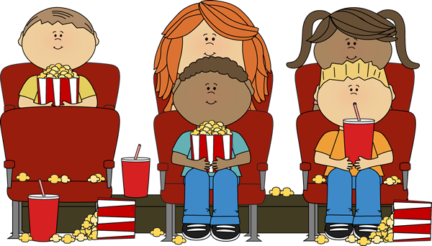
- It pumps blood around in your body. ___________________________________________________

Answers)
- What is a police officer?
- What is a letter?
- What is a family?
- What is Dutch?
- What is a spaceship?
- What is a school?
- What is 1000?
- Who is Barack Obama?
- What are stars?
- What is a ruler?
- What is a traffic light?
- What is a circus?
- What is a lunch box?
- What is a computer?
- What is a rose?
- What is honey?
- What is a pillow?
- Who is Mr / Mrs XX?
- What is Los Angeles.
- What is London?
- What is a salmon?
- What is a snake?
- What is a cinema? (movie theater)
- What is a heart?

