Die Bürgermeisterwahl steht vor der Tür. Die Leute sagen, was sie machen würden, wenn sie Bürgermeister wären.
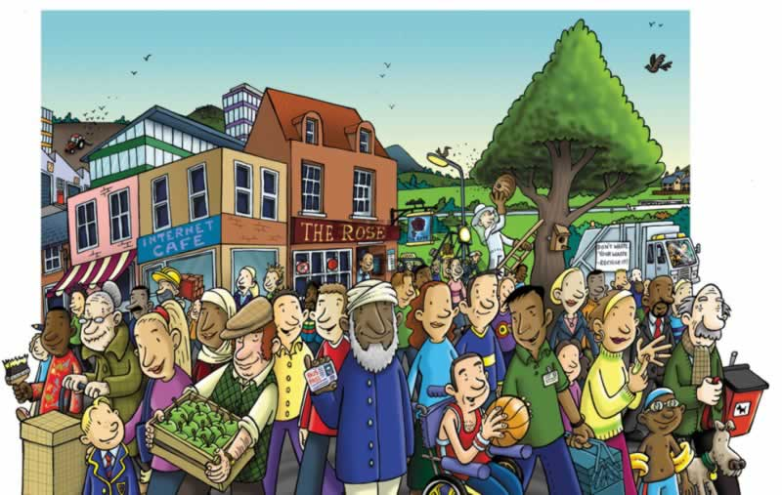
Autos in der Stadtmitte verbieten
öffentliche Gebäude restaurieren
mehr Bäume pflanzen
öffentliche Verkehrsmittel verbessern
Gesundheit verbessern
gratis Eis schenken
ein Jugendzentrum bauen
alten Leuten helfen
Mehr Sportveranstaltungen für Behinderte organisieren
die Steuern verringern

Lehrern besseres Gehalt geben

- __________________________________________________________________
- __________________________________________________________________
- __________________________________________________________________
- __________________________________________________________________
- __________________________________________________________________
- __________________________________________________________________
- __________________________________________________________________
- __________________________________________________________________
- __________________________________________________________________
- __________________________________________________________________
- __________________________________________________________________
- __________________________________________________________________

