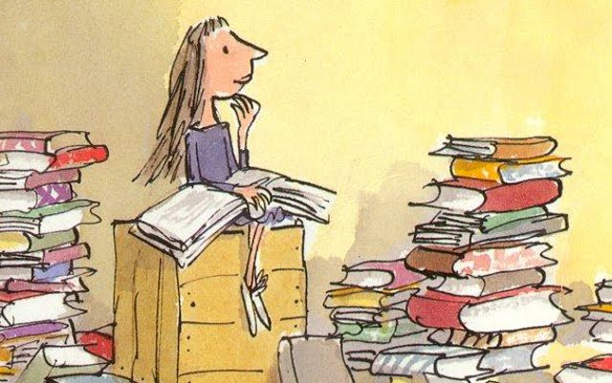

1. Name of the five-year-old girl who reads Dickens and Hemingway.

2. Adjective that describes what Matilda is.

3. Where Matilda goes to in order to get some books.

4. What Mr. Wormwood buys and sells.

5. What does the Wormwoods always do while eating?

6. What Miss Honey does.

7. What is Bruce Bogtrotter forced to eat.

8. The small creature sitting/swimming in the glass of Miss Trunchbull.

9. What you do when you have a disagreement.

10. Something that sticks two things together.

11. To tell someone that something bad or dangerous may happen.

12. Who is Miss Honey’s aunt? Miss……

13. A document that states who should receive your possessions when you die.

14. Where Matilda’s parents and brother are headed for.

15. Whom does Matilda stay with when her parents leave?

16. What do the children play on Miss Trunchbull?

17. What sticks to Mr. Wormwood’s head?

N

O

H

**15**

S

I

M

**14**

S

P

A

II

N

**13**

W

I

L

**12**

L

L

U

B

H

C

N

U

R

**11**

W

N

R

U

L

G

**10**

E

U

G

R

**9**

V

T

H

C

T

A

**5**

W

**8**

N

E

W

A

K

E

C

E

T

A

L

O

C

O

C

**7**

**6**

T

E

H

C

A

**4**

C

A

R

S

D

**1**

M

A

T

I

**2**

C

L

E

V

E

Y

R

A

R

B

I

L

**3**

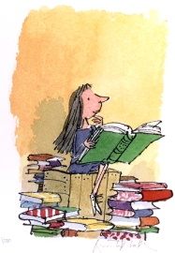

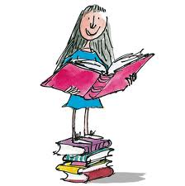

**17**

T

A

E

J

K

**16**

Y

E